**Emergency and Mental Wellbeing**

**Project Statement:**

The Emergency and Wellness Management System addresses the growing need for personal safety and mental well-being. This platform allows users to report emergencies, receive notifications, and track their mental health through assessments. It also provides personalized recommendations and access to support resources for improved well-being and safety.

**Milestone – 1:(User Authentication)**

• Implement user registration functionality.

• Develop user login mechanism.

**Dependencies:**

🡪Lombok

🡪spring data JPA

🡪Spring security

🡪Spring web

🡪MySQL driver

🡪Oauth

**Packages & Classes:**

**🡪**Controller

* AuthController

🡪DTO

* LoginDto
* RegisterDto
* UpdateDto

🡪Config

* SecurityConfig

🡪Model

* Person

🡪Repository

* PersonRepository

🡪Serive

* PersonService

**Model :**

Define models to represent user data.

**Class: Person**

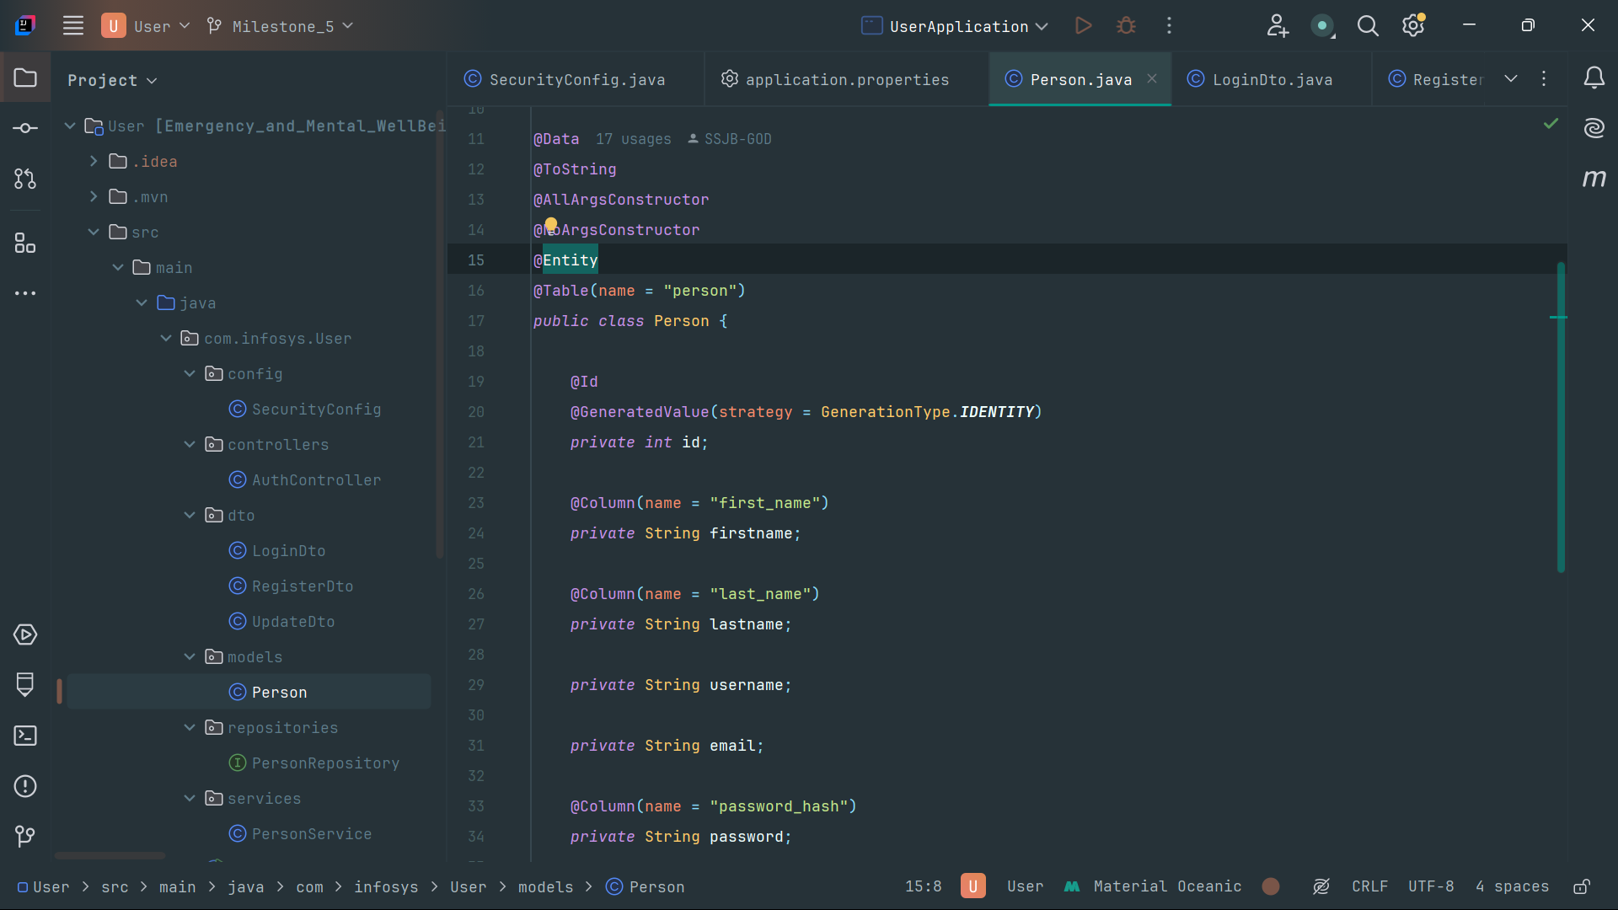

**Controller:**

Define Controller to HTTP requests.

**Class: AuthController**

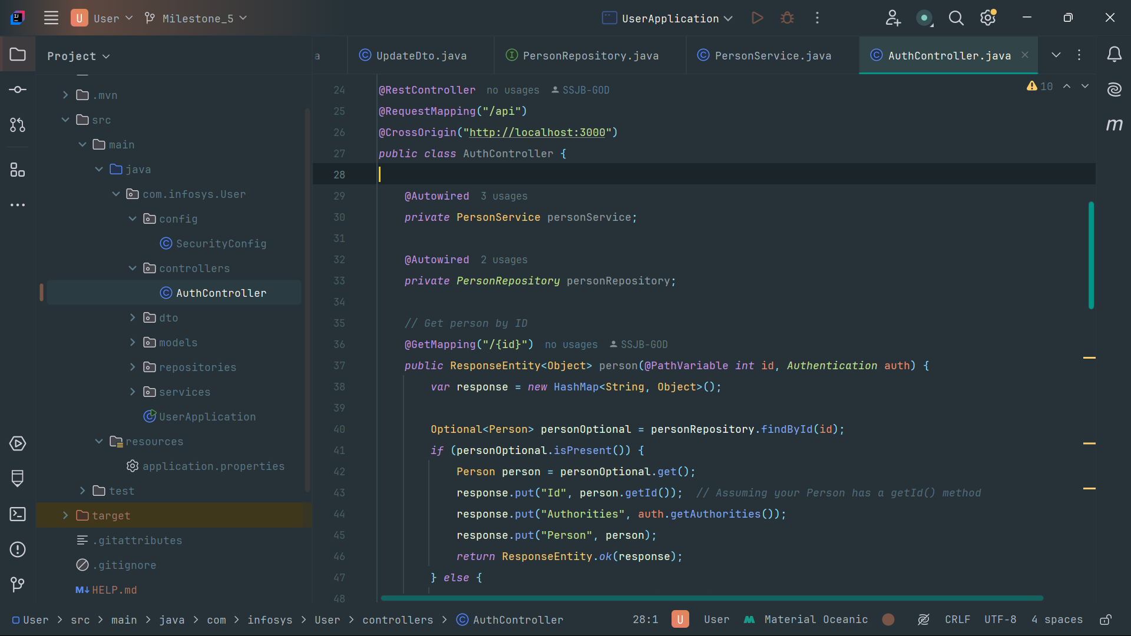

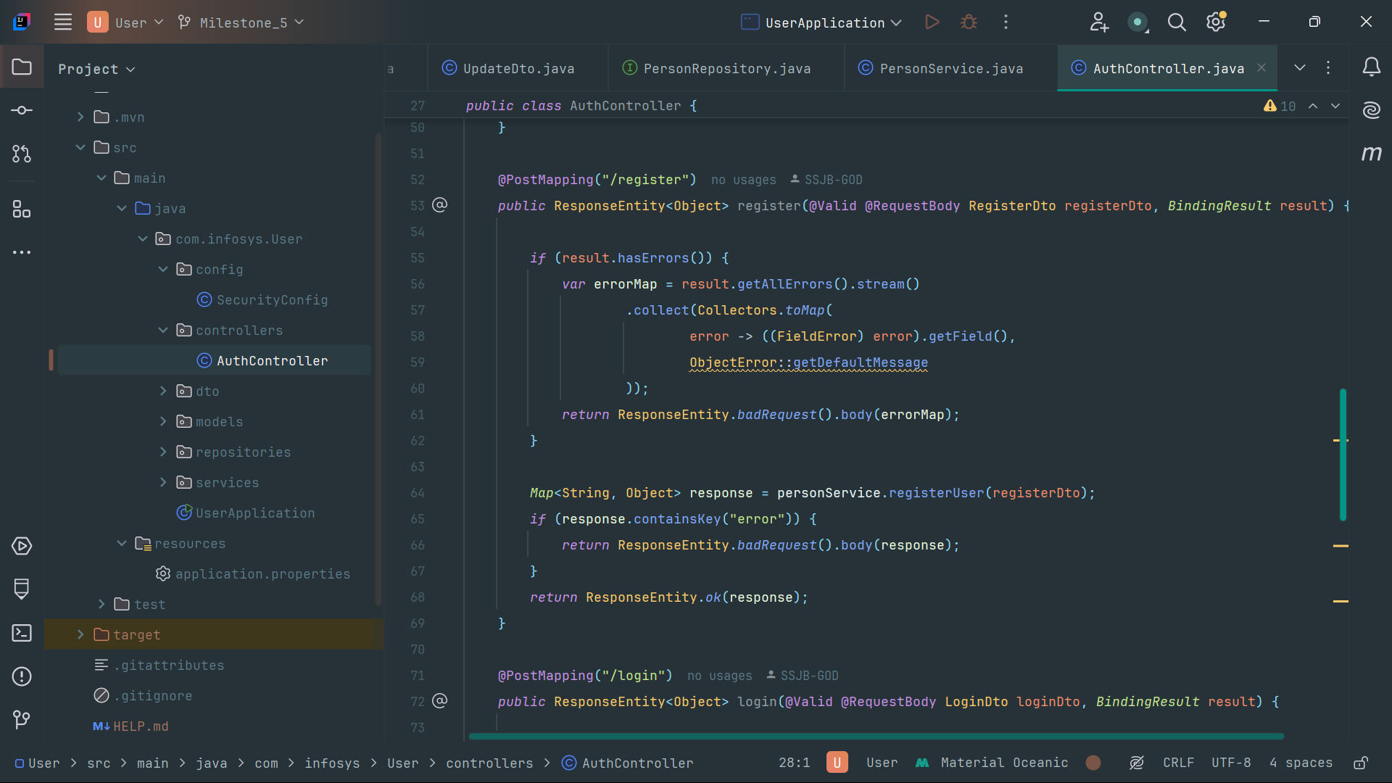

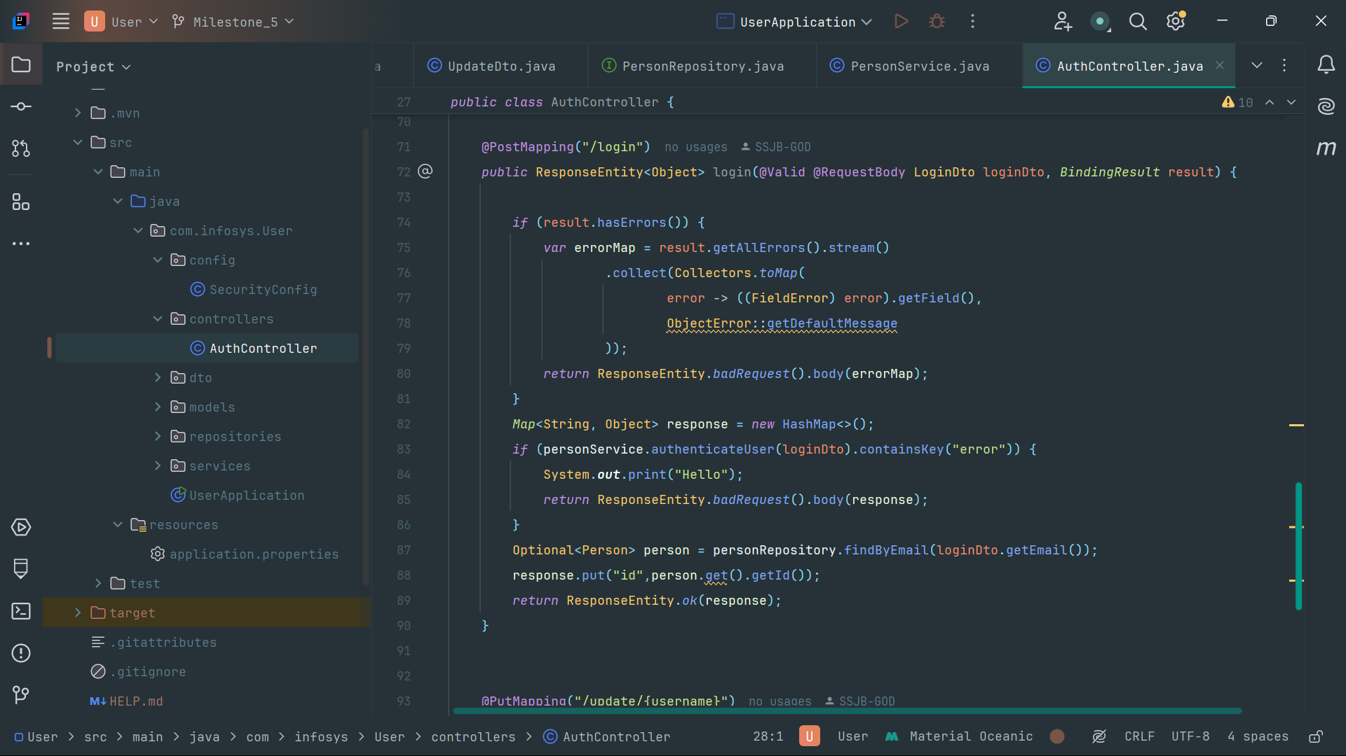

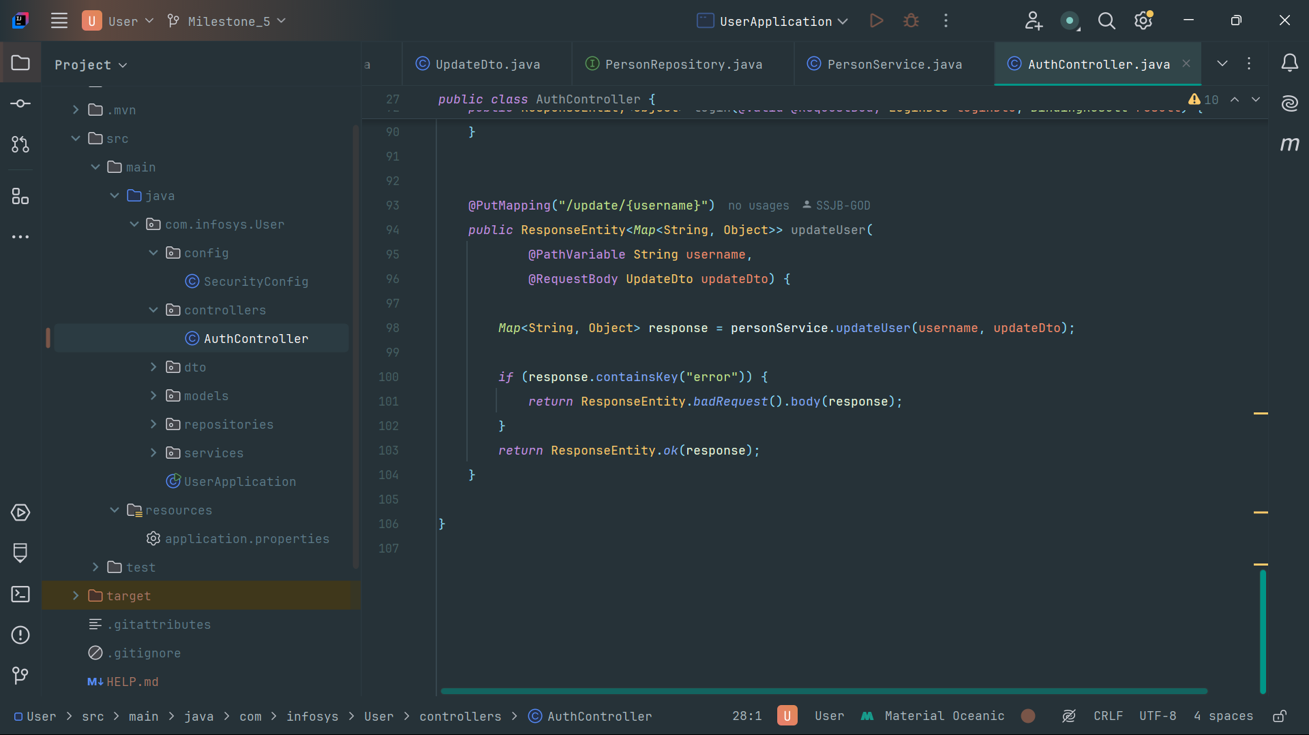

**DTOs:**

Define DTOs to handle registration data.

**Class: LoginDto**

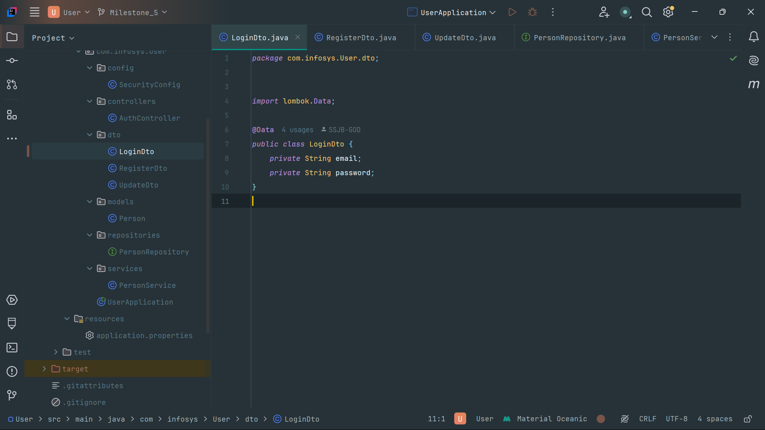

**Class: RegisterDto**

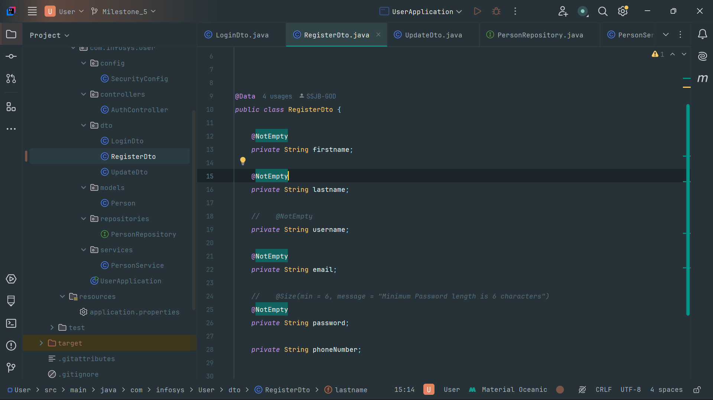

**Class: UpdateDto**

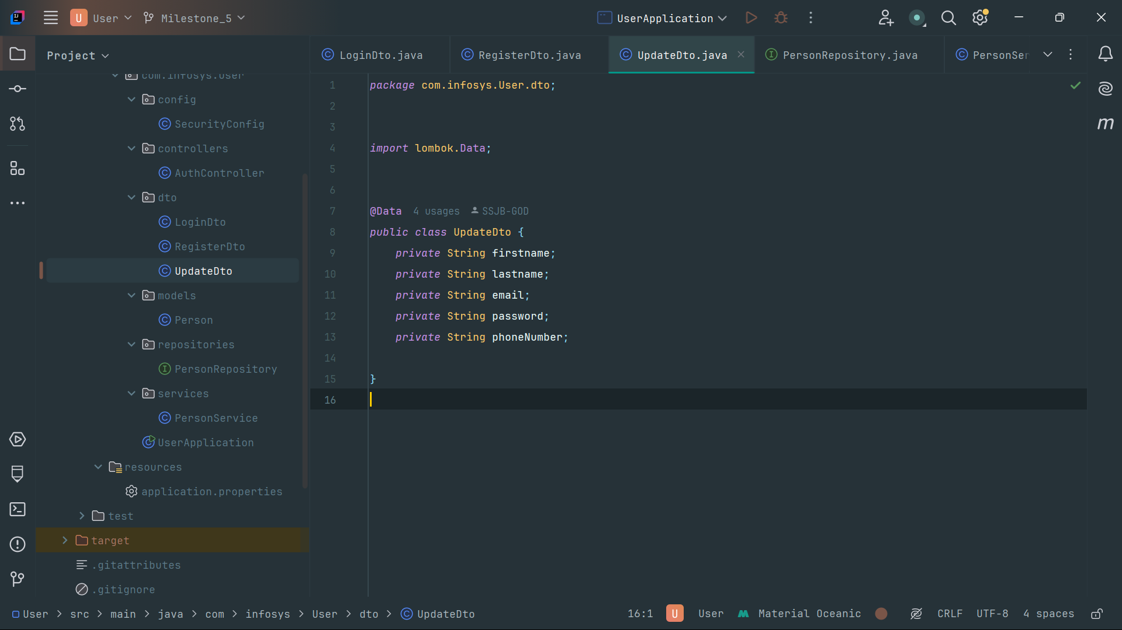

**Repository :**

Create Repositories for database interactions

**Class: PersonRepository**

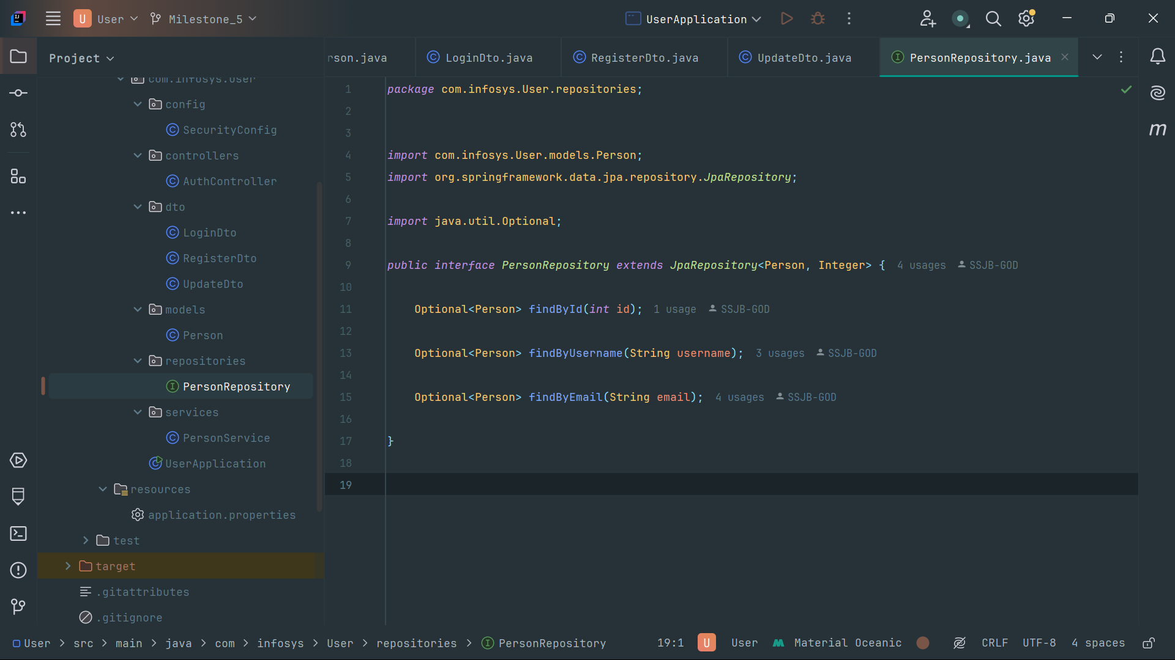

**Service:**

Create service classes to handle business logic.

**Class: PersonService**

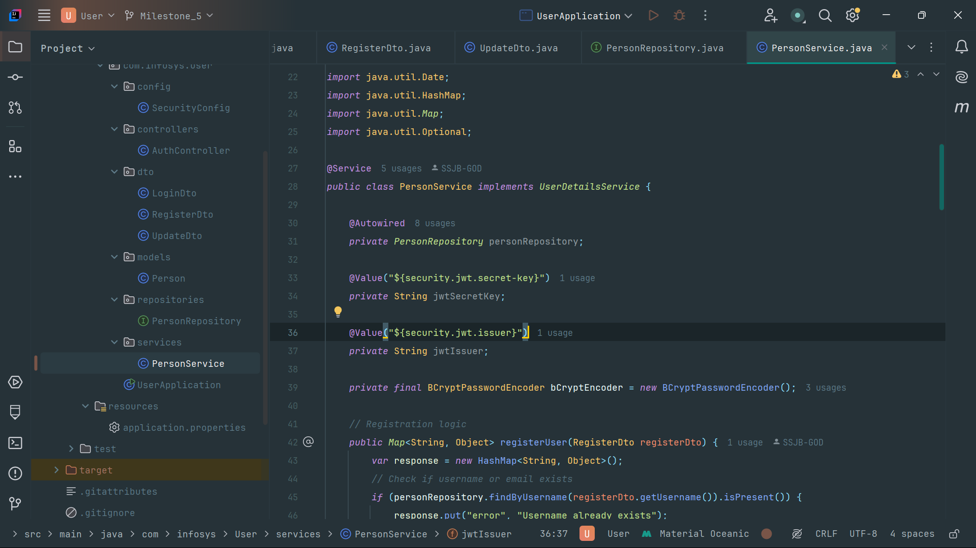

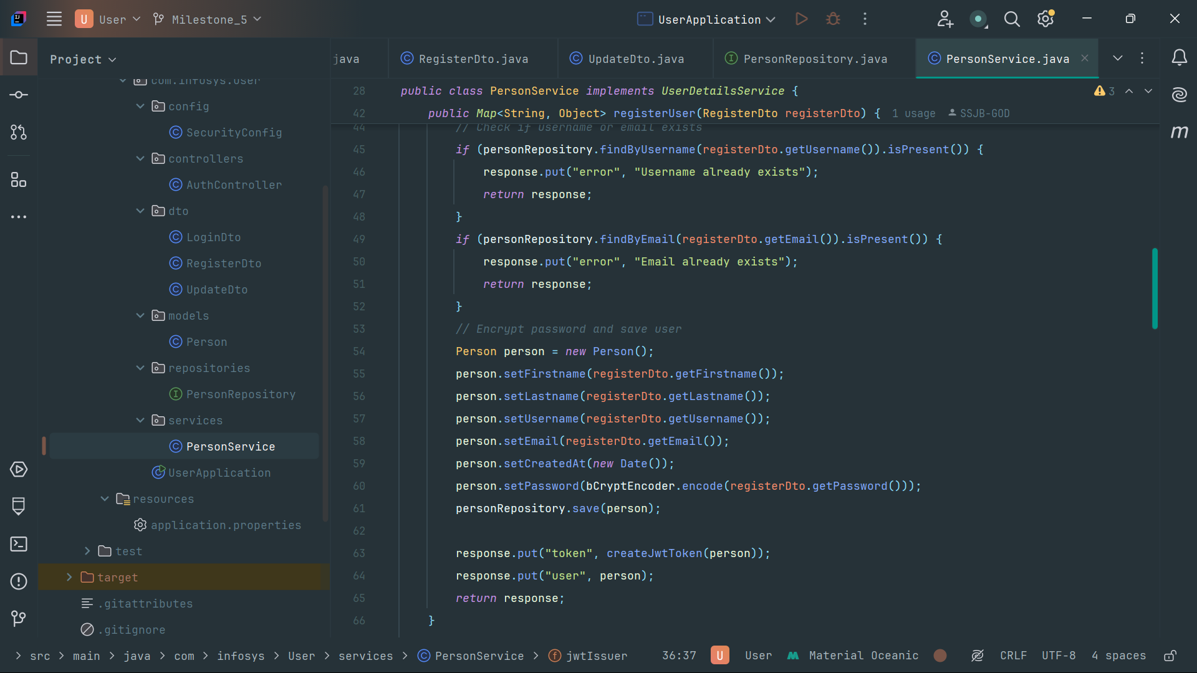

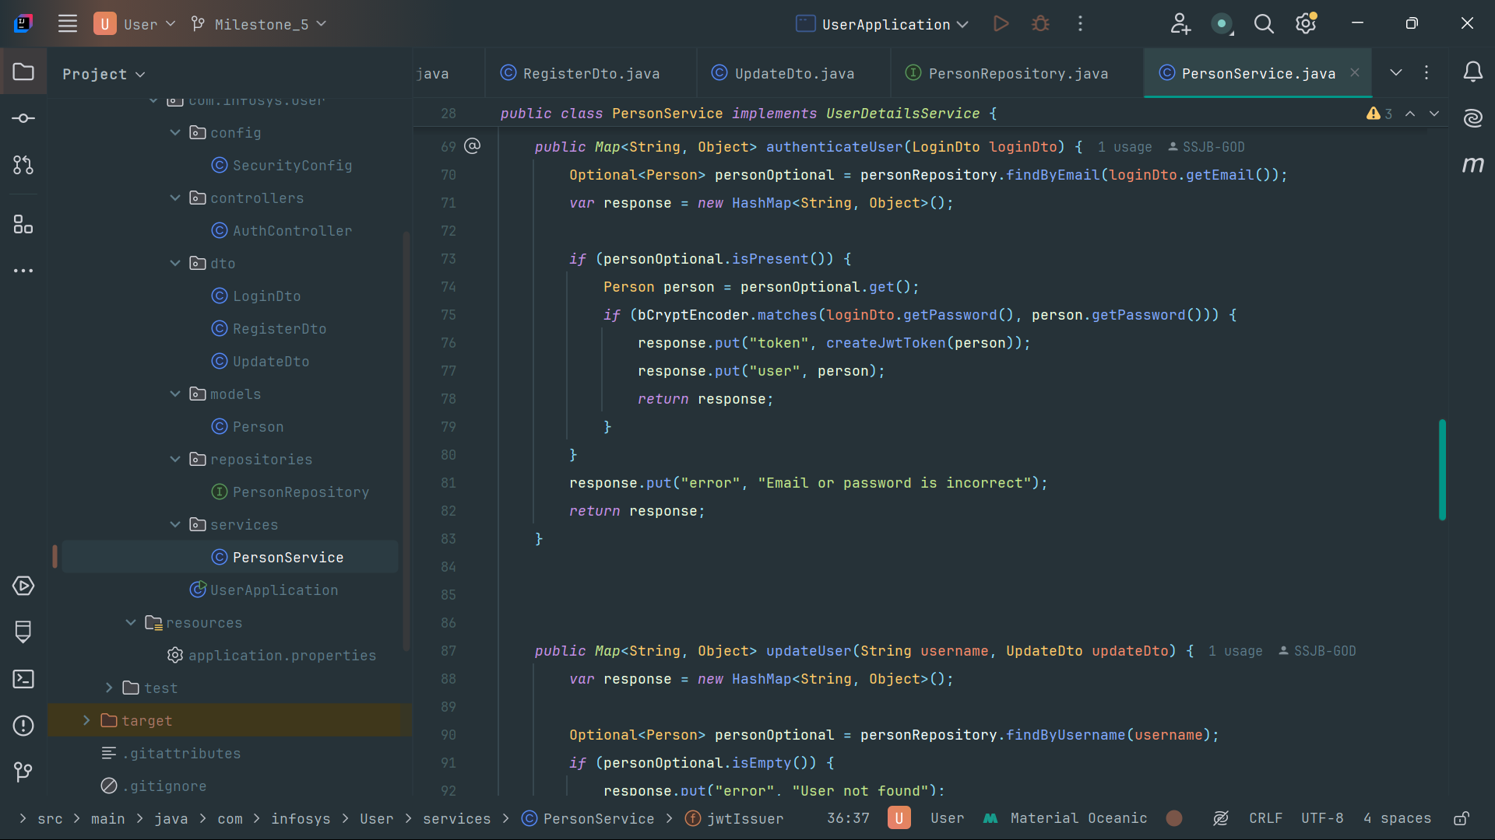

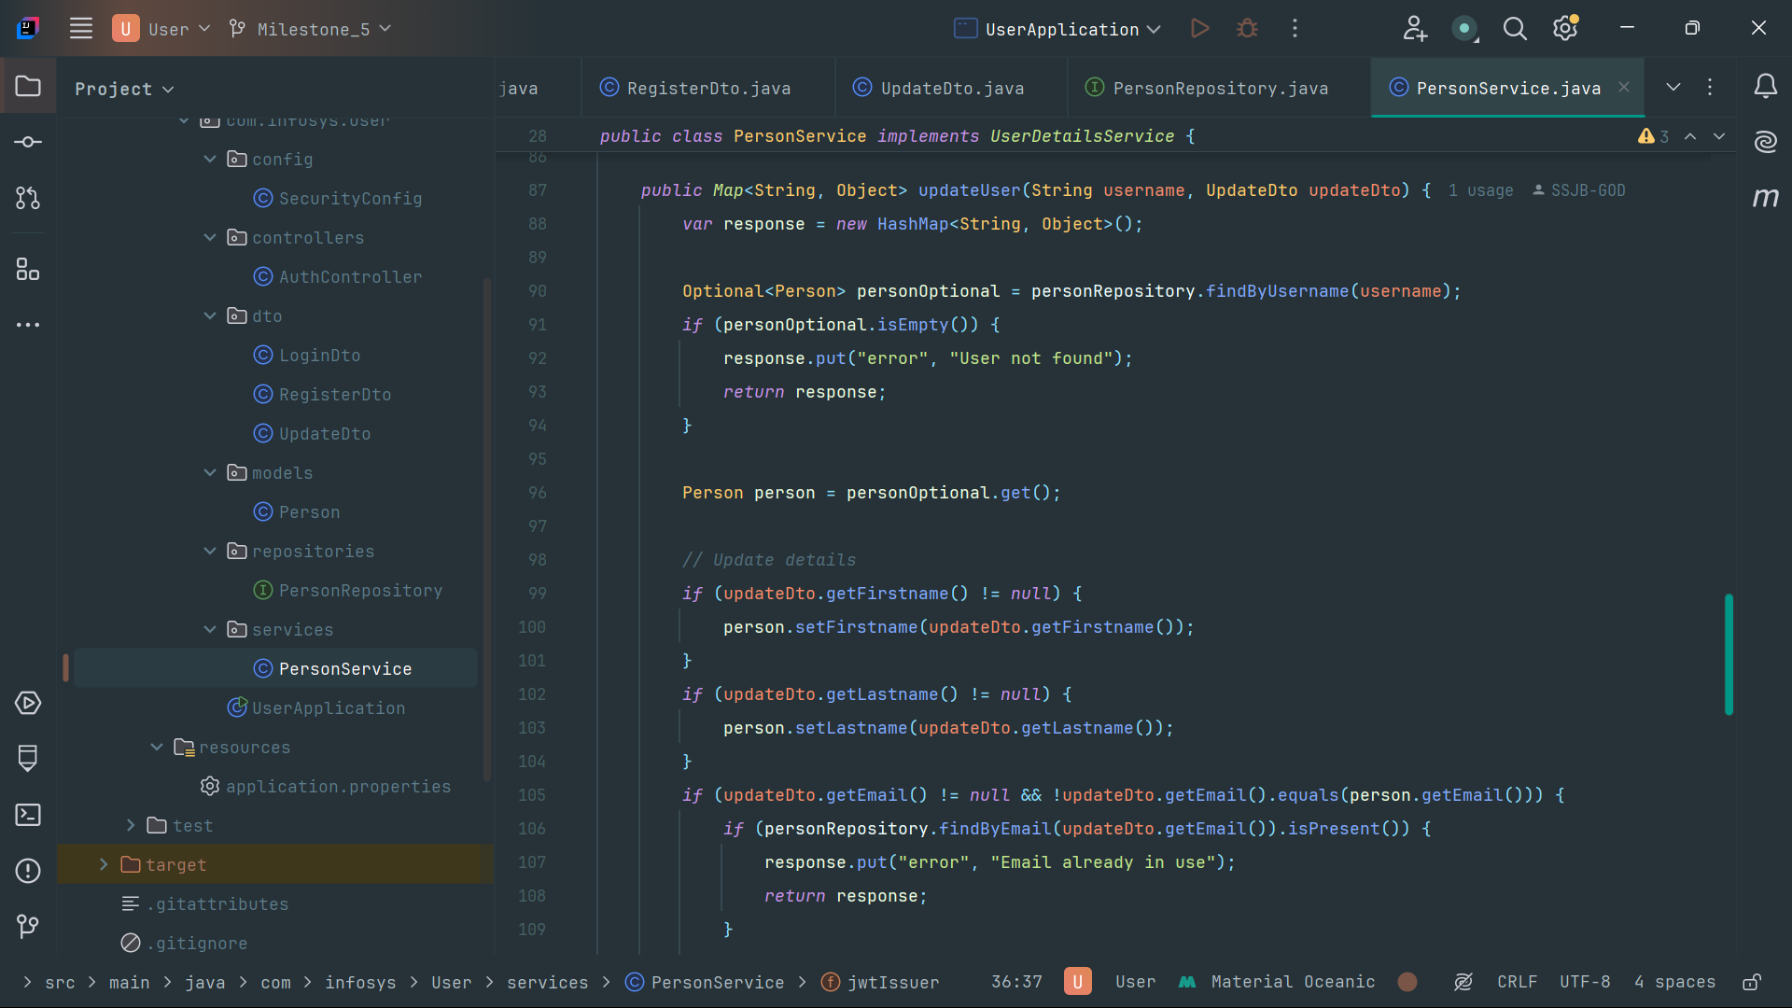

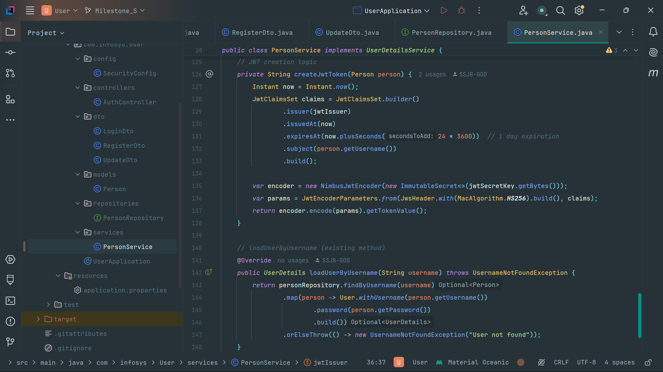

**Config:**

Create Config for Security Configurations.

**Class:SecurityConfig**

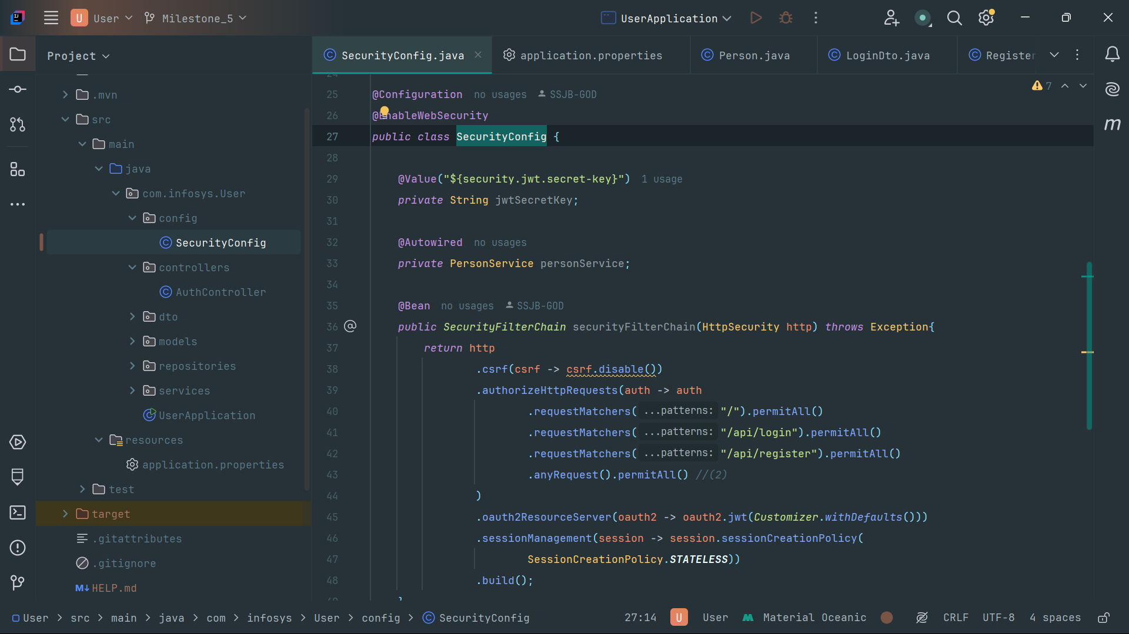

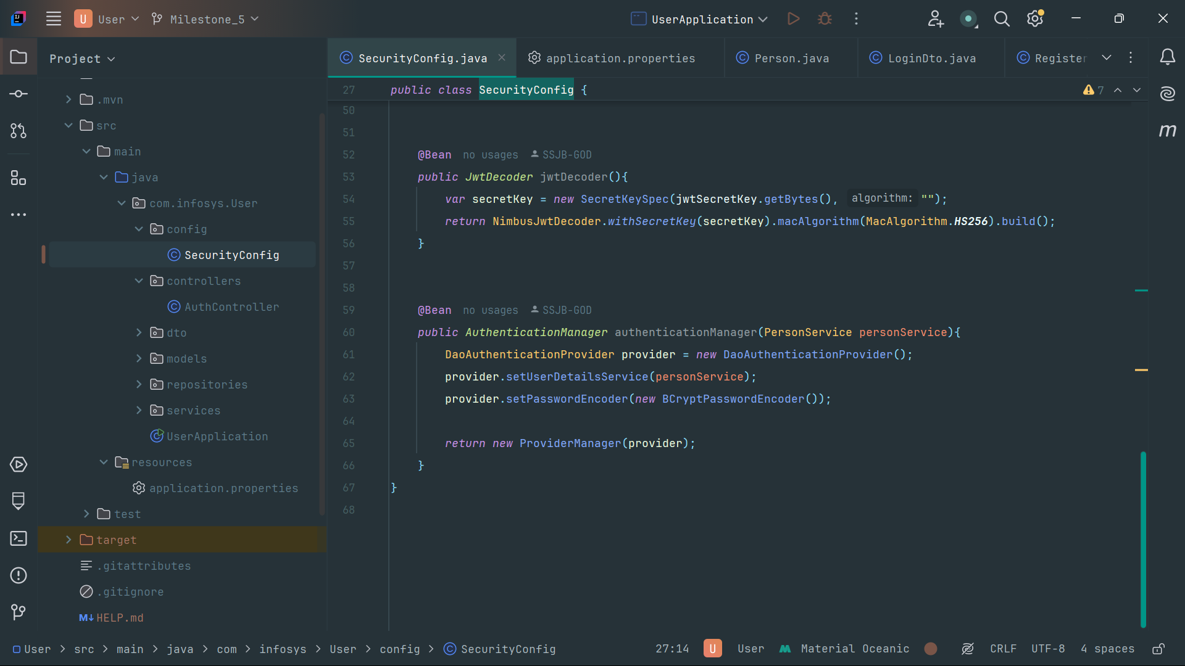

**Application properties**

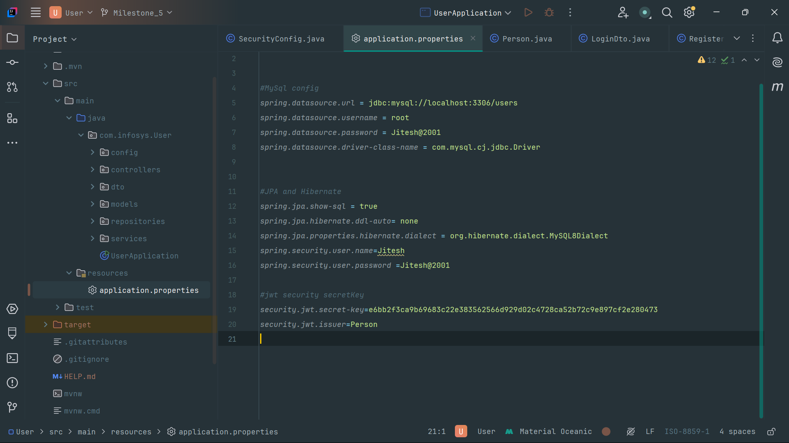

**Testing and Validation**

Test the application using Postman or other tools to ensure endpoints work as expected.

**POST api/register**

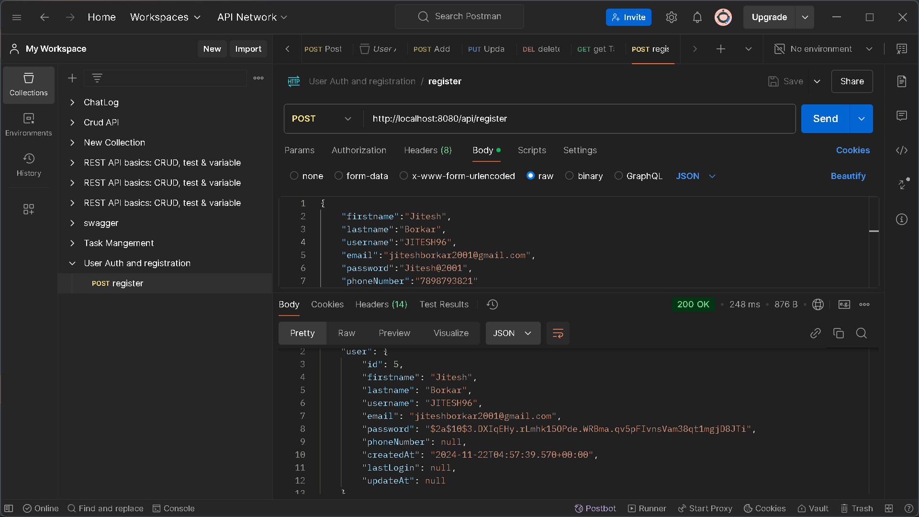

**POST api/login**

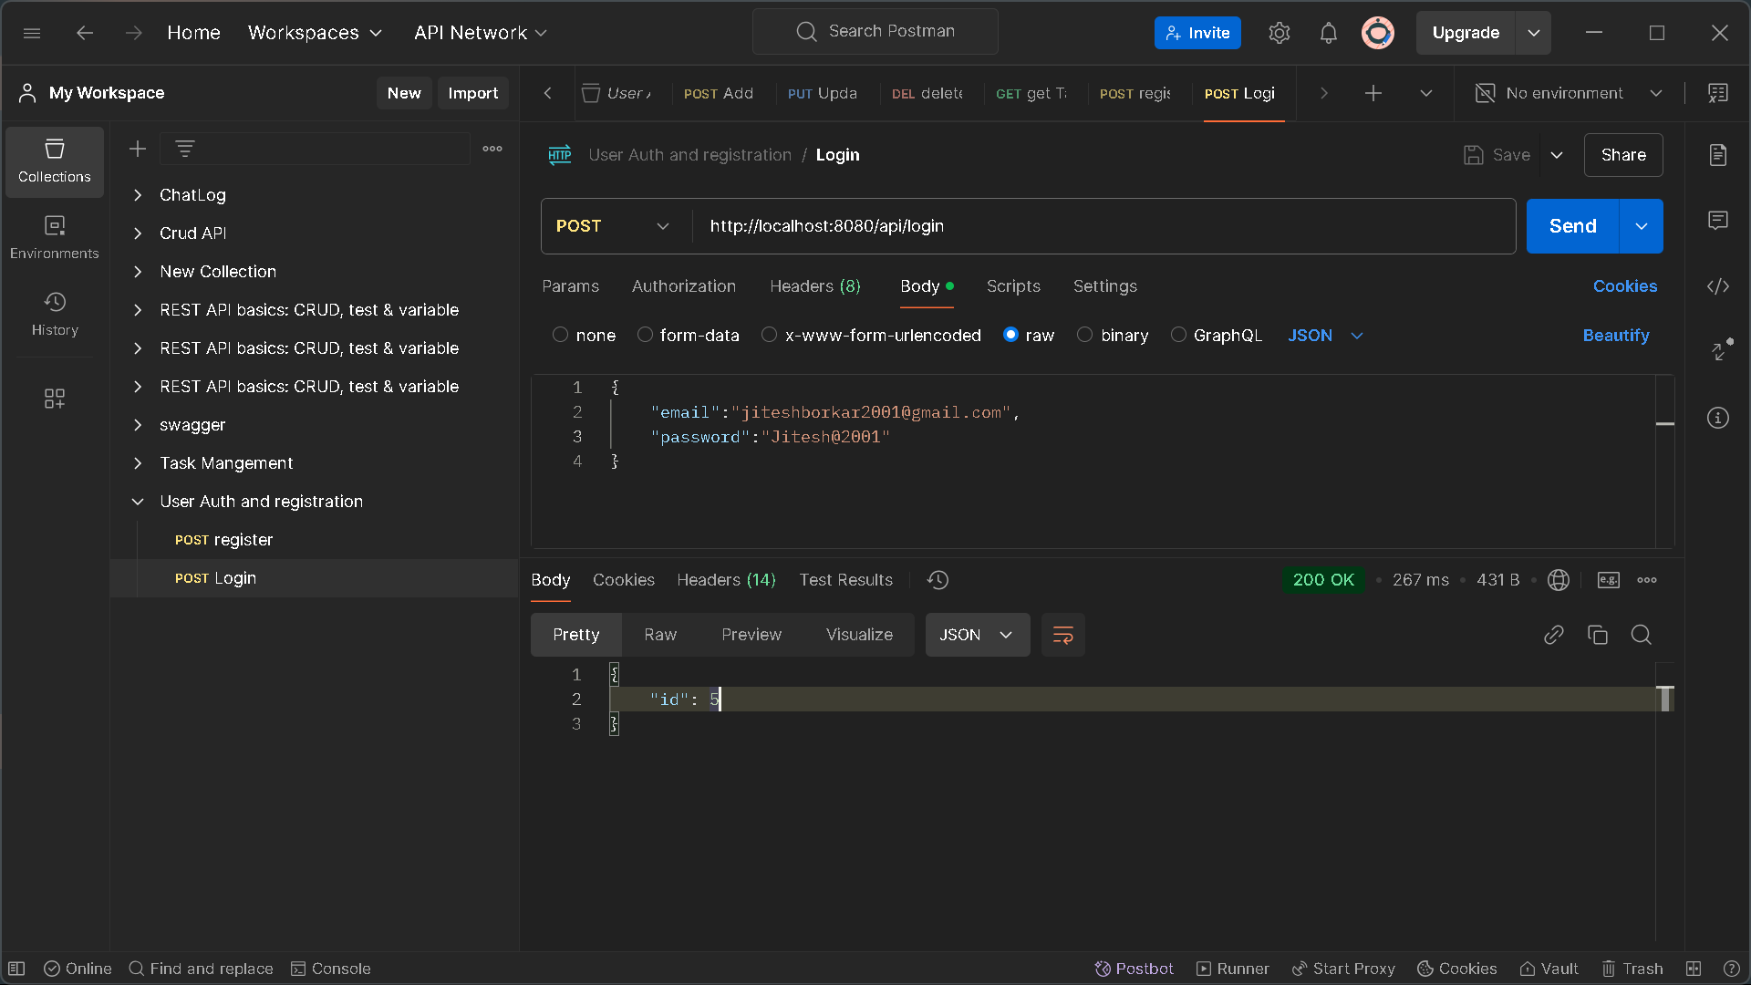

**PUT api/update/{username}**

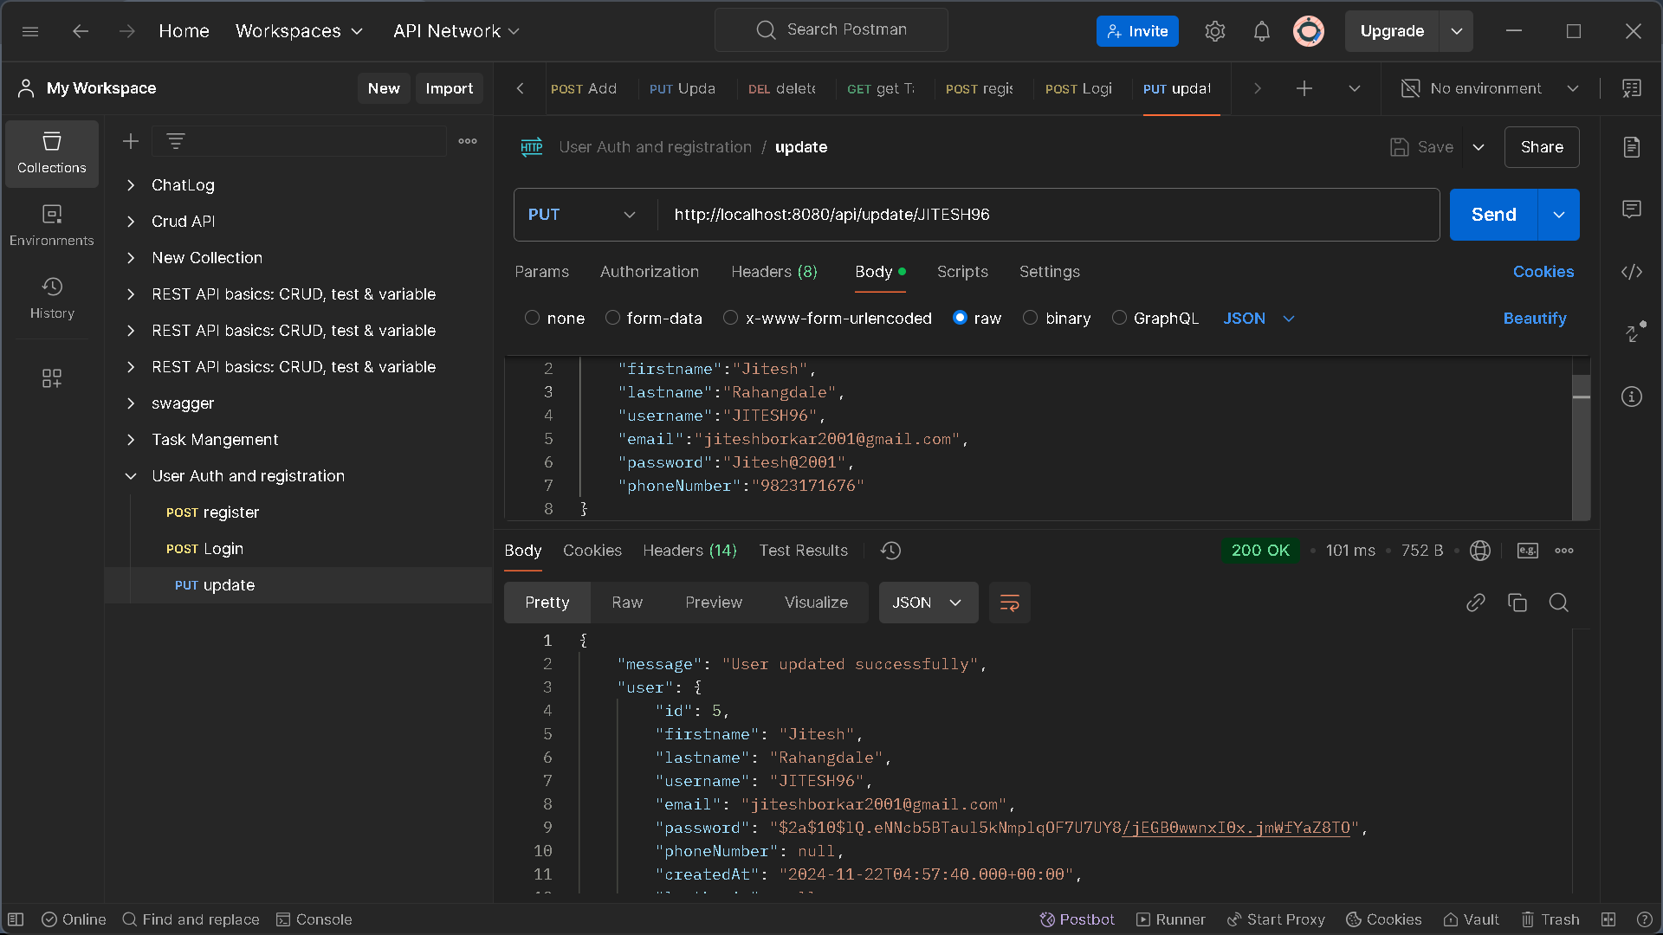

**GET api/{id}**

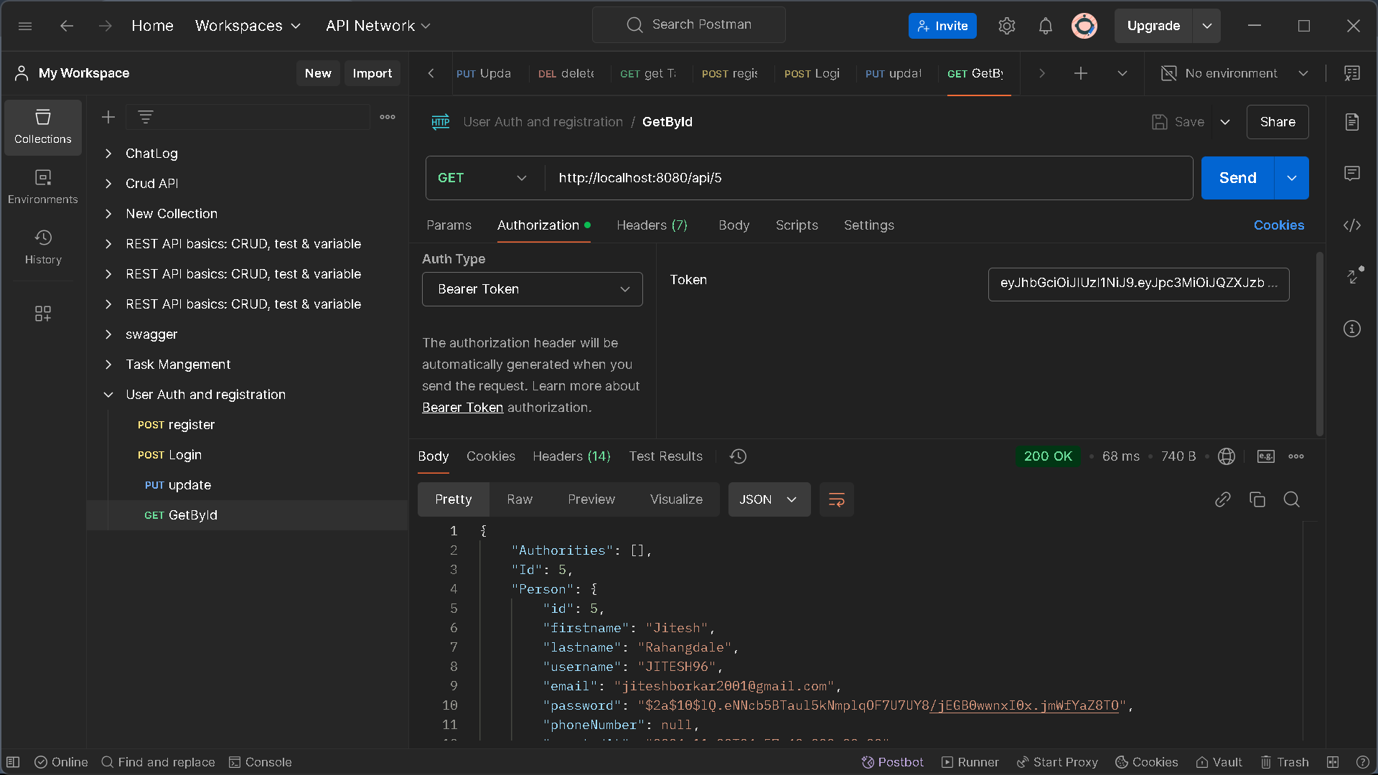

**Conclusion:**

This outline provides a foundational structure for a backend for User Authentication and Registration.

**Milestone – 2:**

The Assessment module evaluates a user's mental health by prompting them to respond to depression-related questions. Based on their answers, the system utilizes a scoring algorithm to assess their mental health status. Once the score is generated, the user receives personalized recommendations and resources tailored to their specific needs ensuring users have access to relevant and helpful guidance for improving their well-being.

**Dependencies:**

🡪Lombok

🡪spring data JPA

🡪Spring data MongoDB

🡪Spring web

🡪MySQL driver

**Packages & Classes:**

**🡪**Controller

* QuestionController
* WellbeingTestController

🡪DTO

* WellbeingTestDTO

🡪Exception

* GlobalExceptionHandler

🡪Model

* Choice
* Question
* WellbeingTest

🡪Repository

* QuestionRepository
* WellbeingTestRepo

🡪Serive

* QuestionService
* WellbeingService
* WellbeingServiceImpl

**Model :**

User: Represents a user taking the assessment.

Questionnaire: Stores questions and options.

Assessment: Tracks the results of the assessment.

TestHistory: Logs completed assessments for each user.

**Class: Choice**

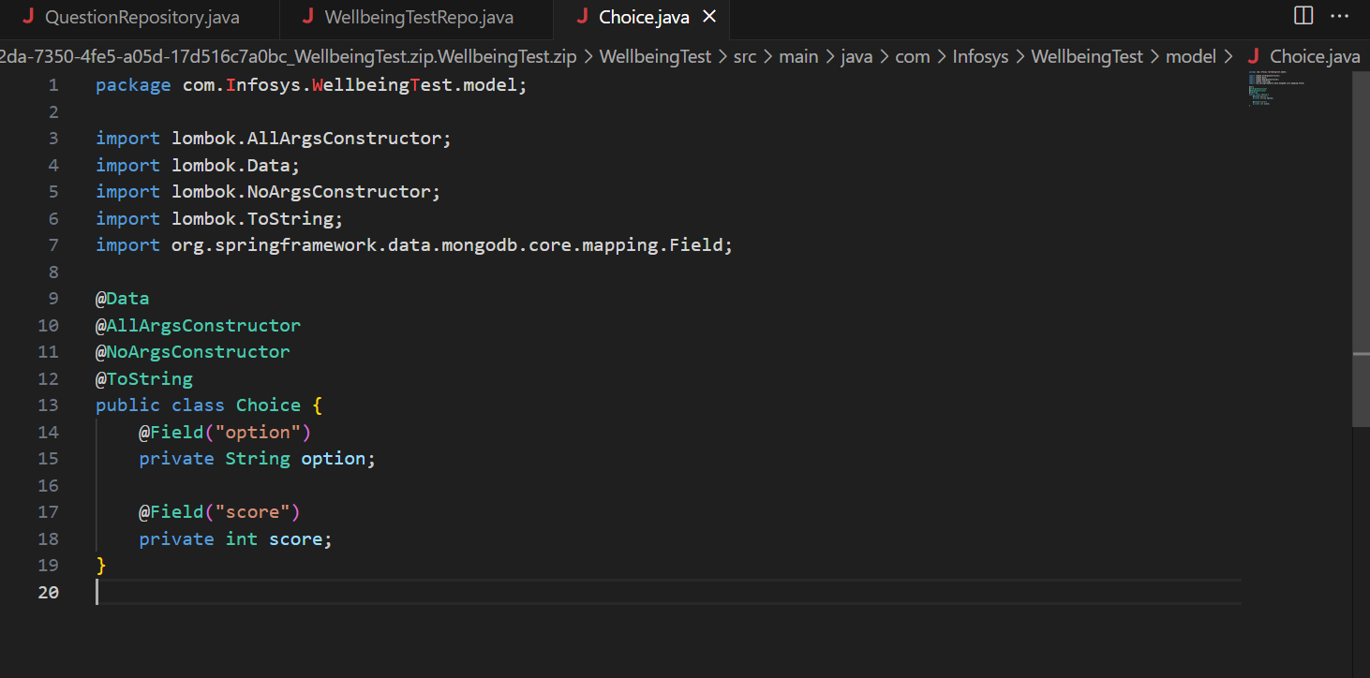

**Class : Question**

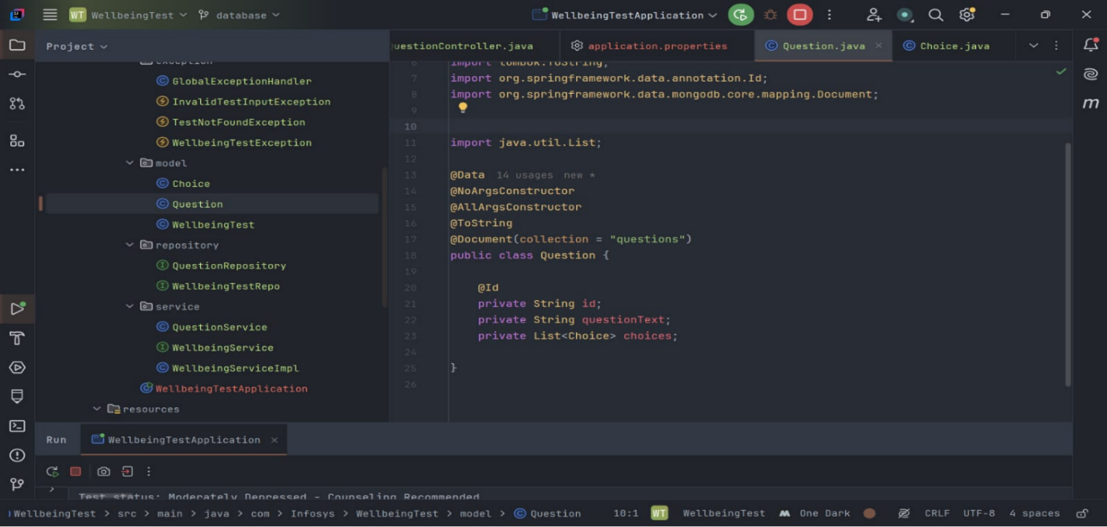

**Class : WellbeingTest**

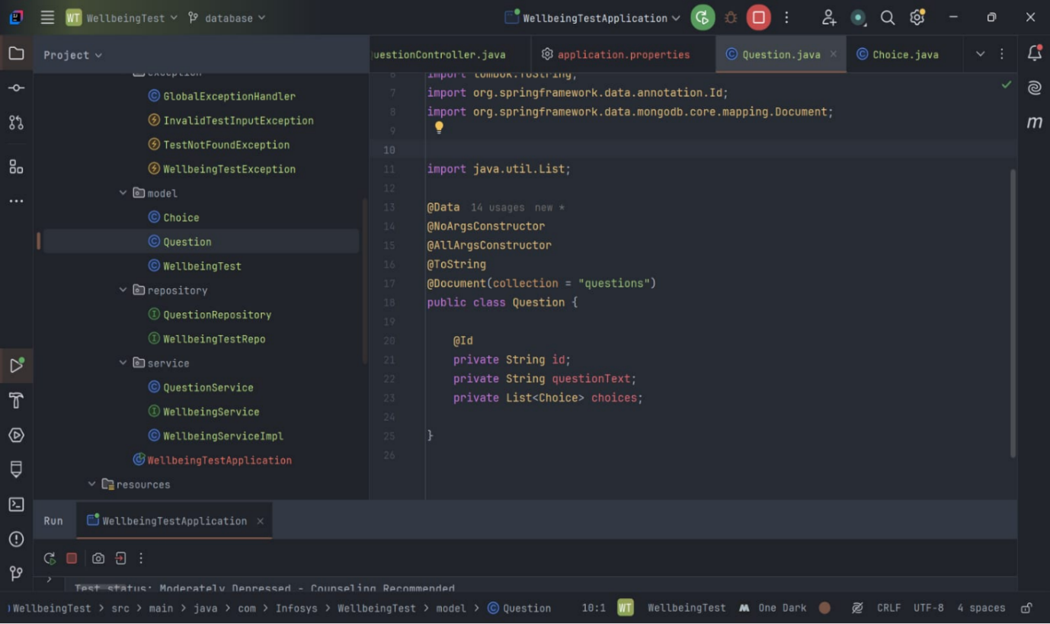

**Repository :**

Define JPA repositories for each entity

**Class: QuestionRepository**

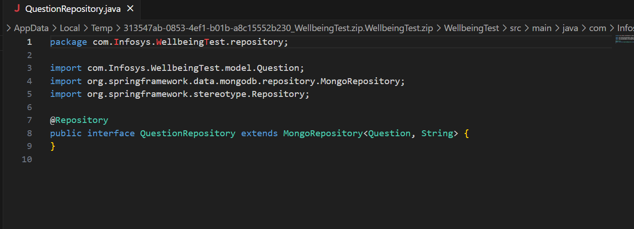

**Class: WellbeingTestRepo**

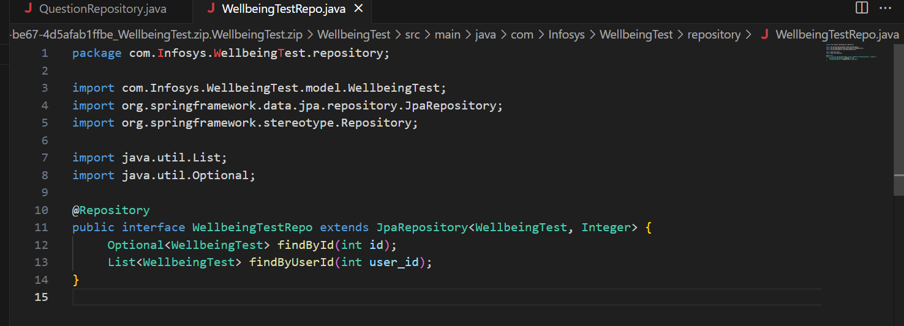

**Service:**

Create service classes to handle business logic, such as saving answers, calculating assessment scores, and logging test history.

**Class: QuestionService**

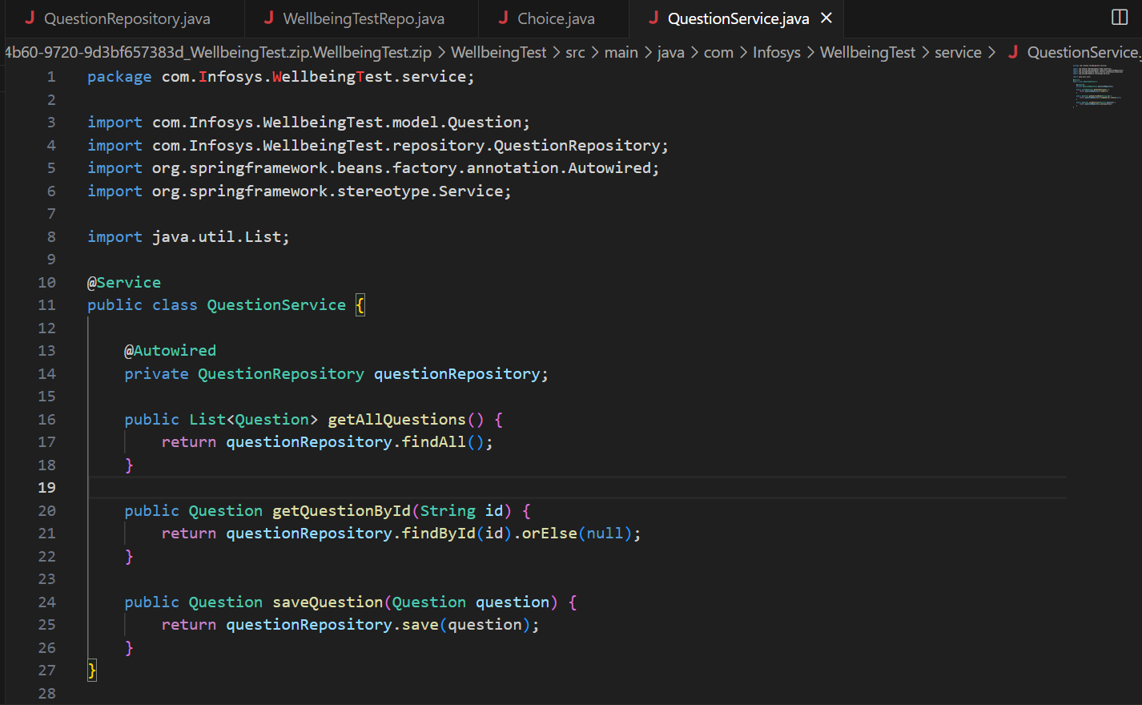

**Class: WellbeingService**

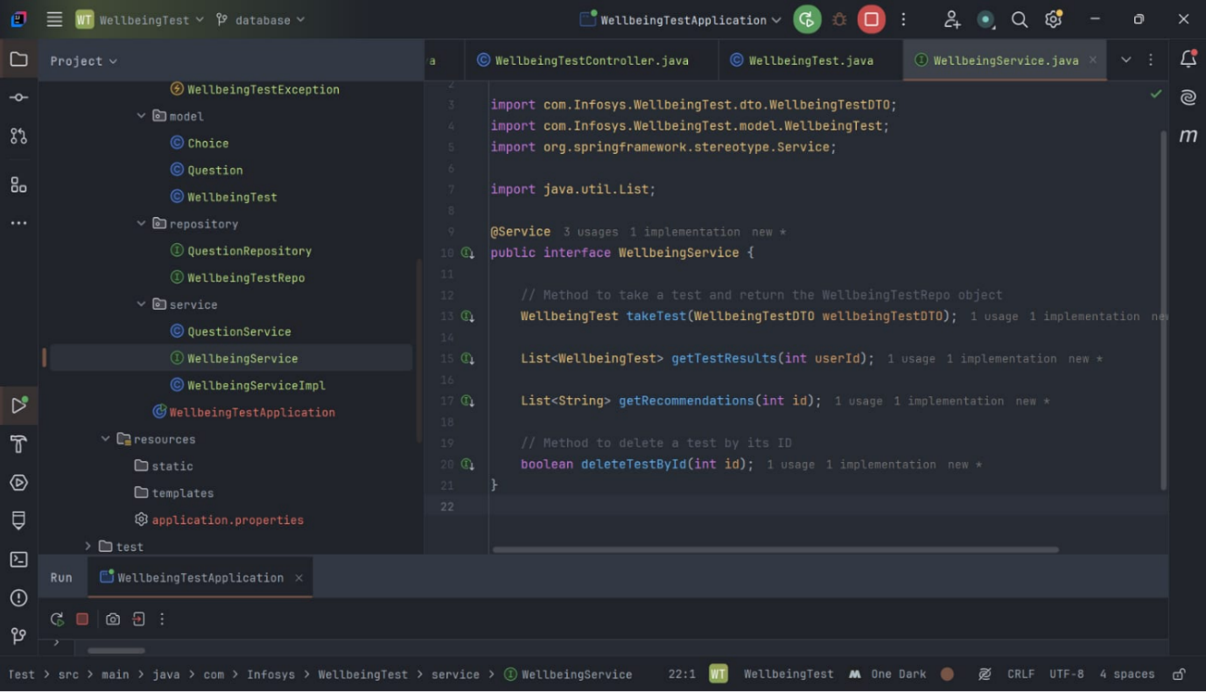

**Class: WellbeignServiceImpl**

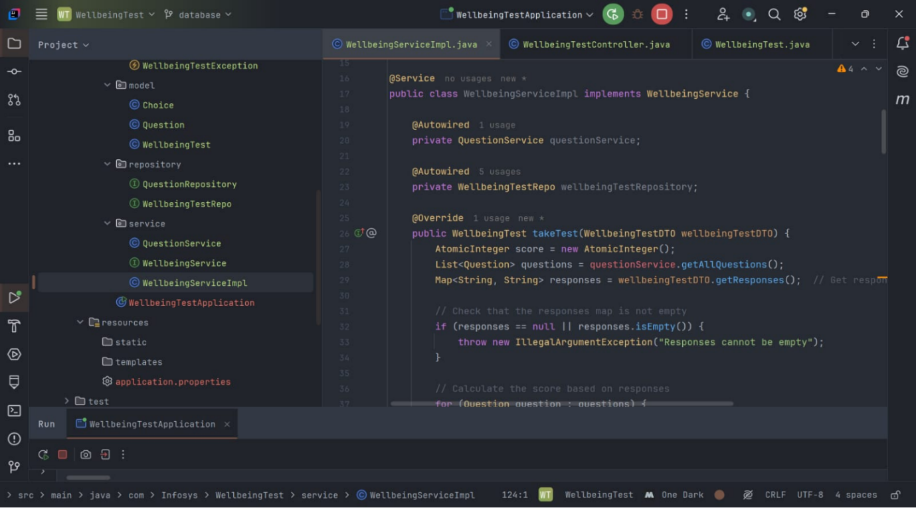

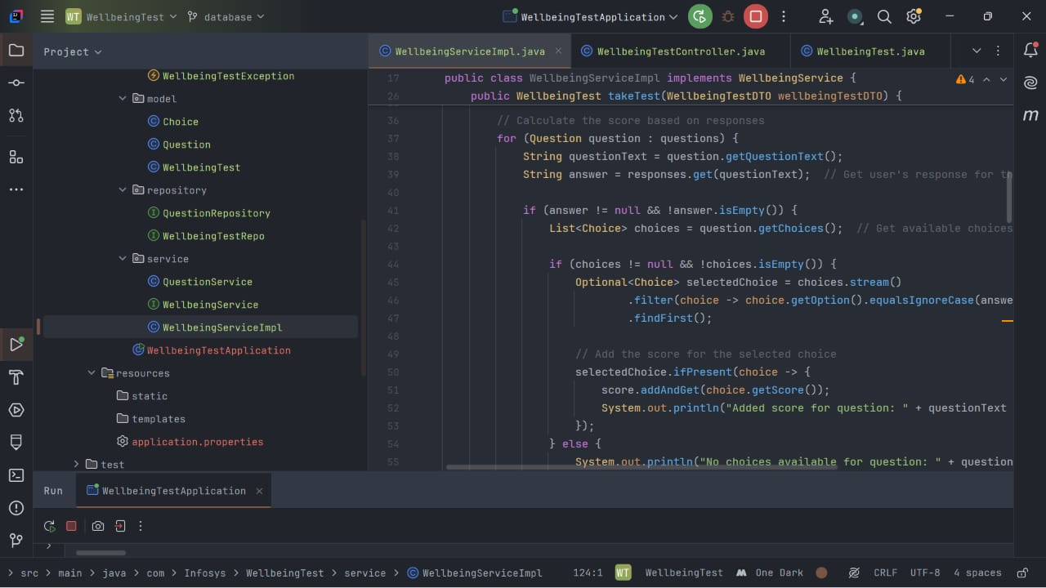

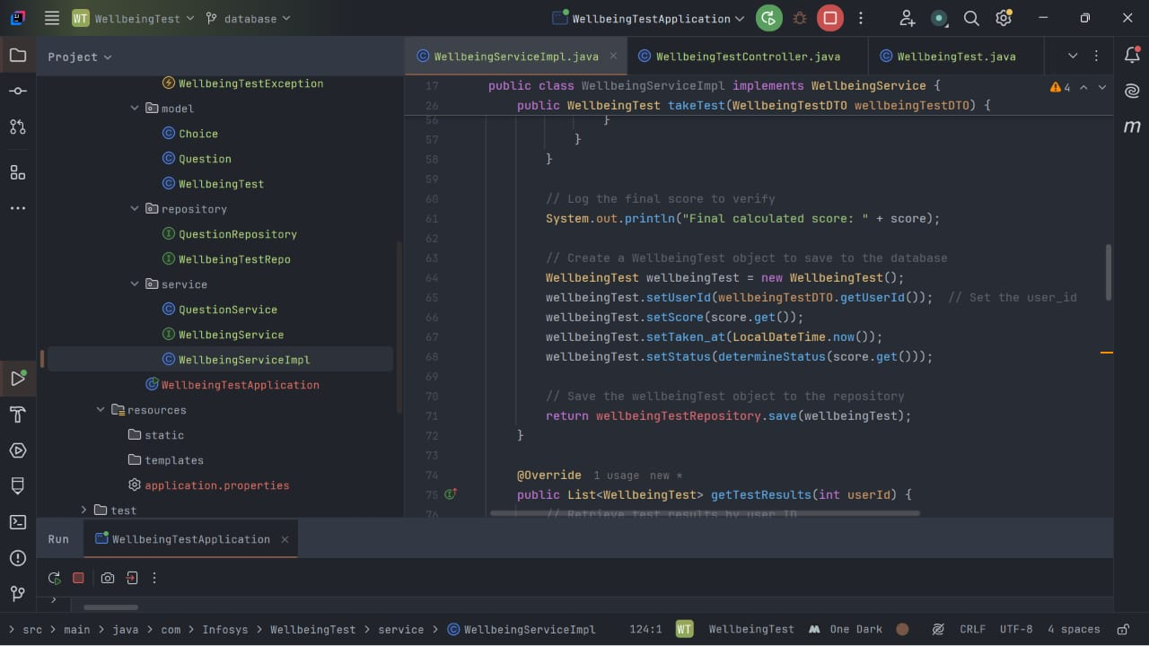

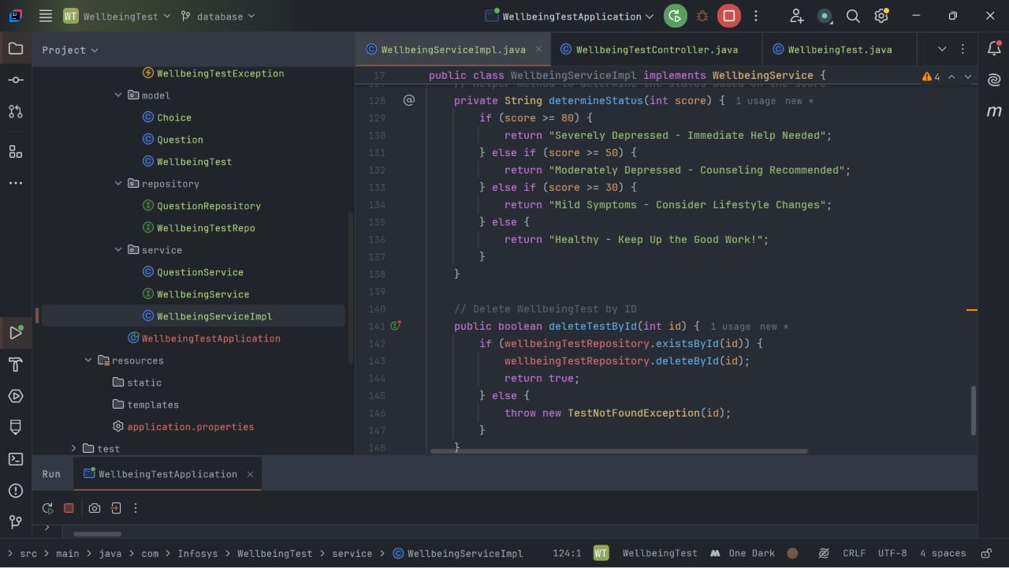

**Controller :**

Create REST controllers to handle API requests, like saving answers, retrieving questionnaires, and fetching test histories.

**Class: QuestionController**

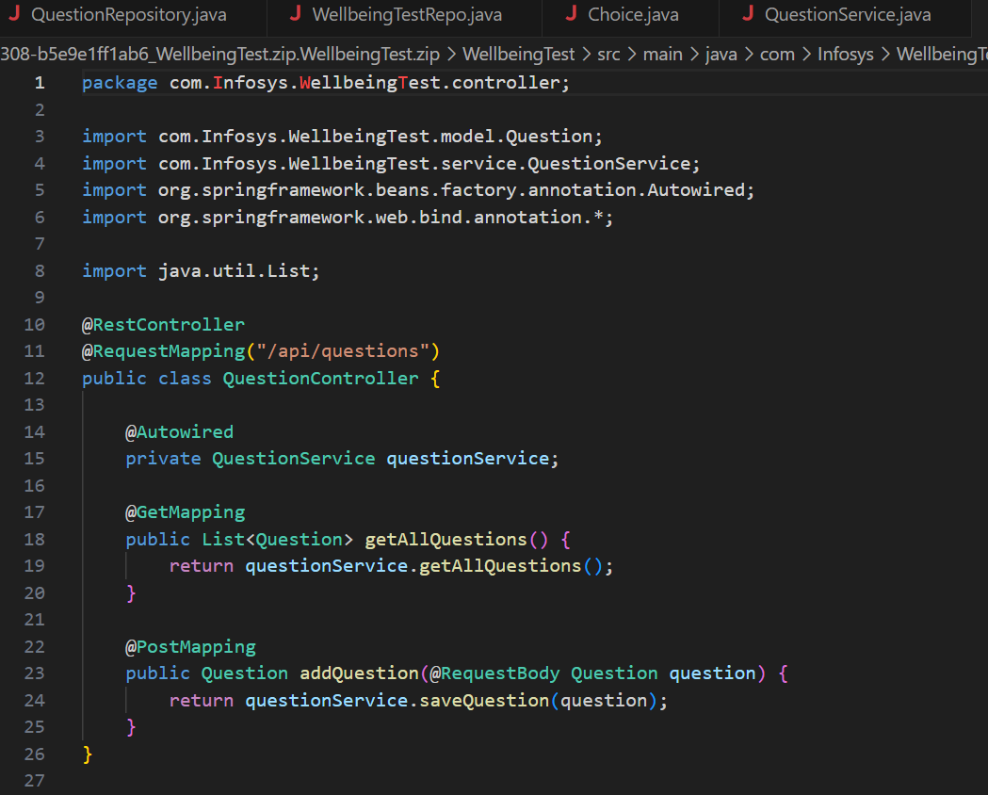

**Class: WellbeingTestController**

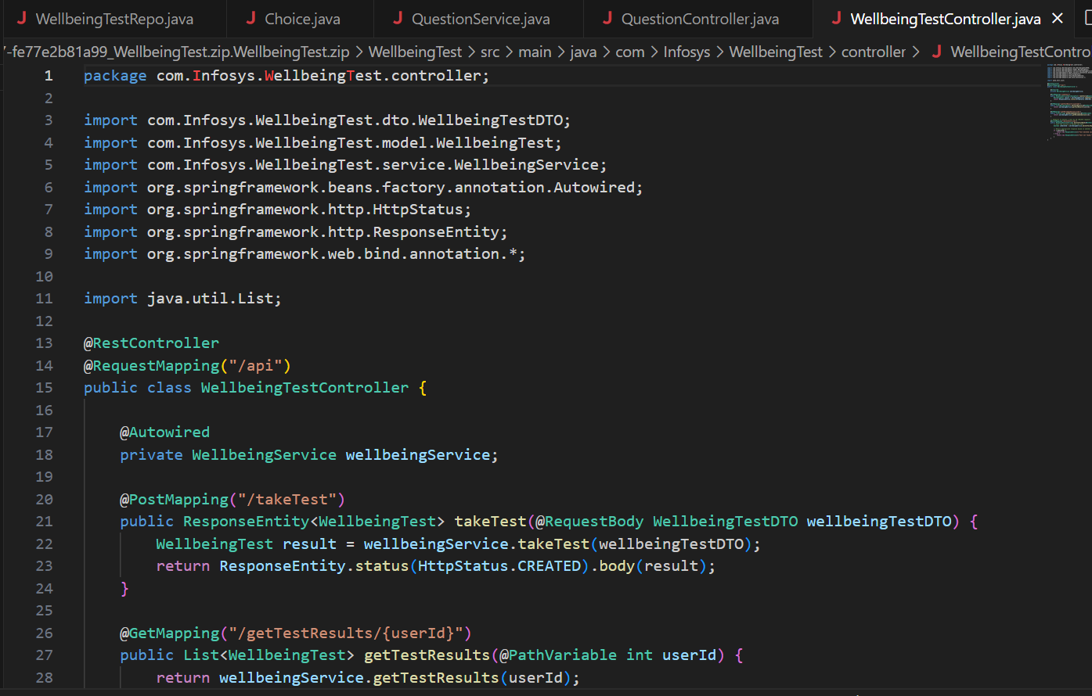

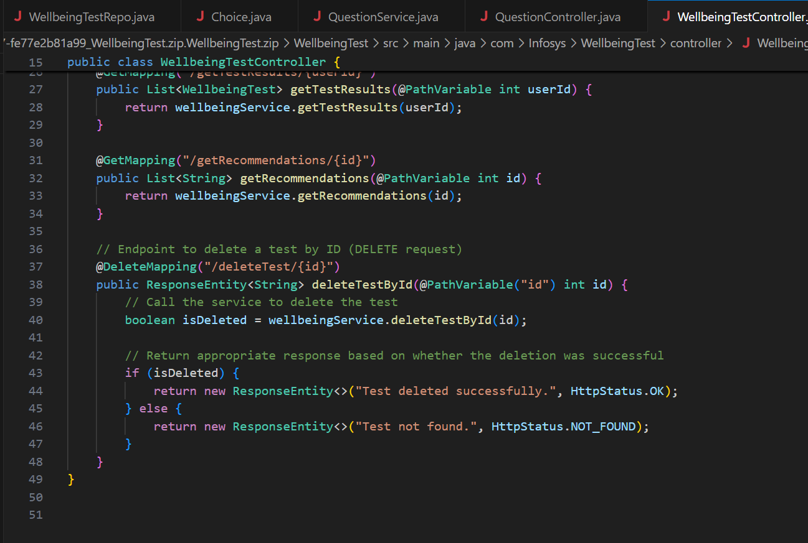

**DTO :**

DTOs will help ensure that only the necessary information is sent to the client

**Class : WellbeingTestDTO**

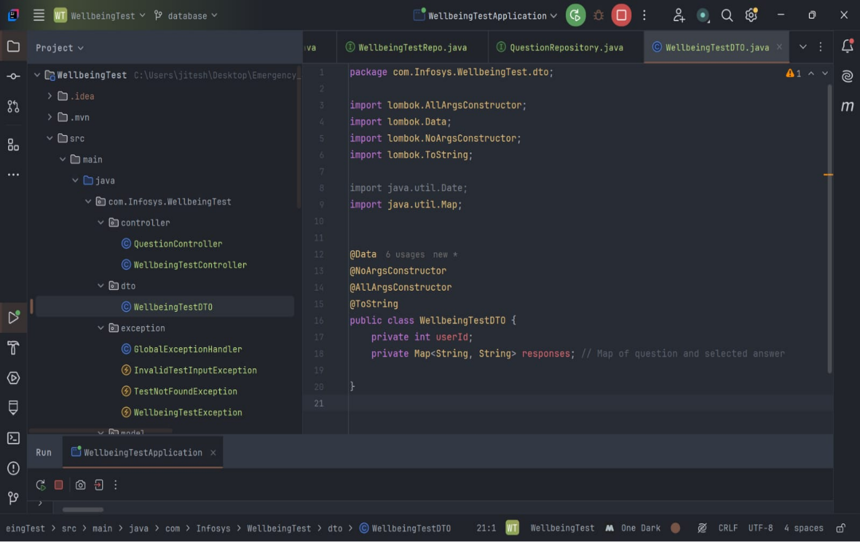

**Testing and Validation**

Test the application using Postman or other tools to ensure endpoints work as expected.

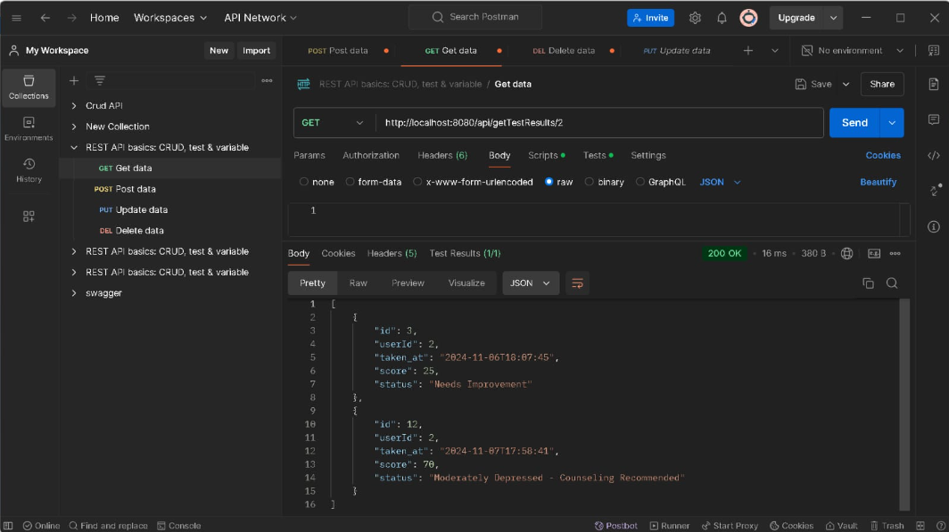

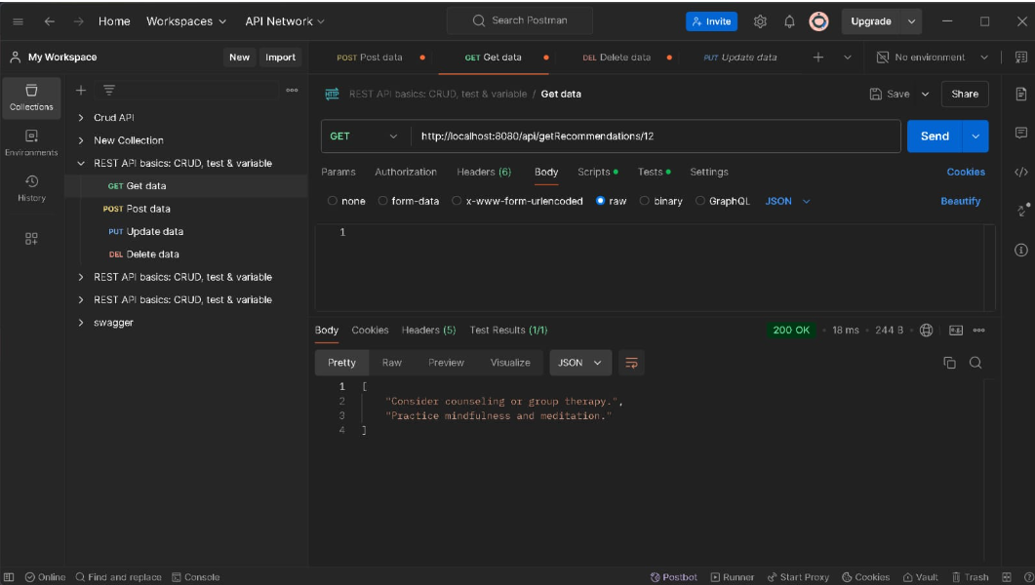

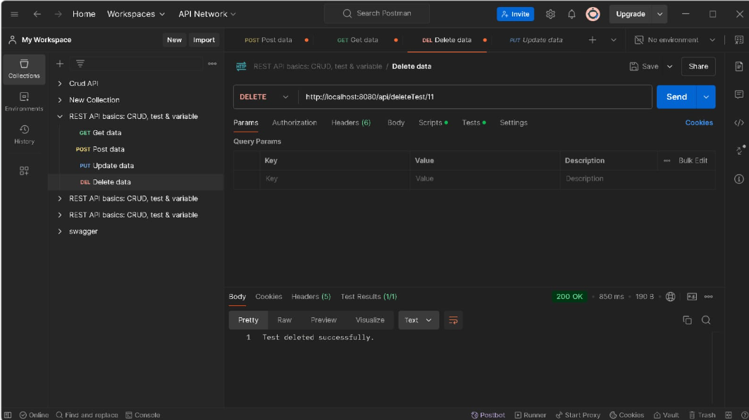

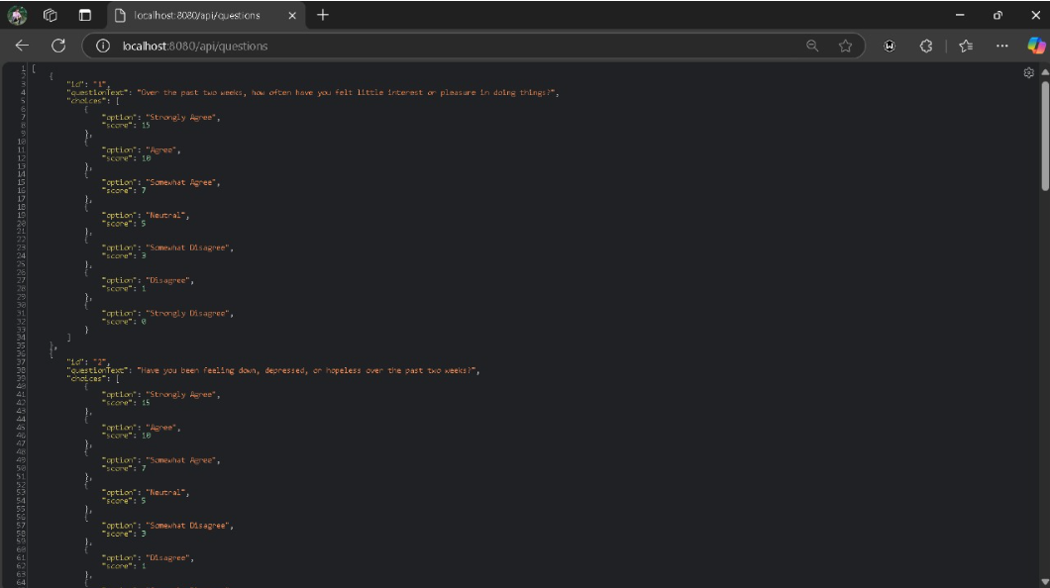

**MongoDB**

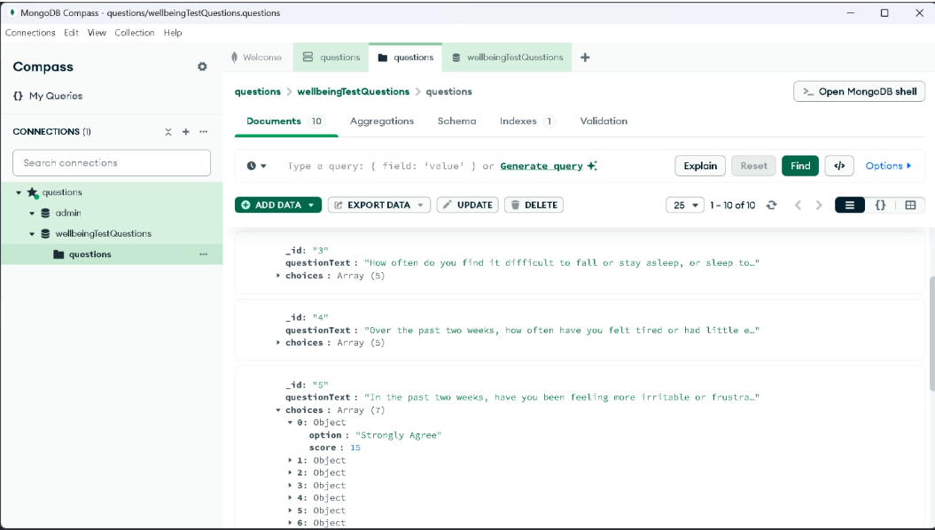

**MySQL**

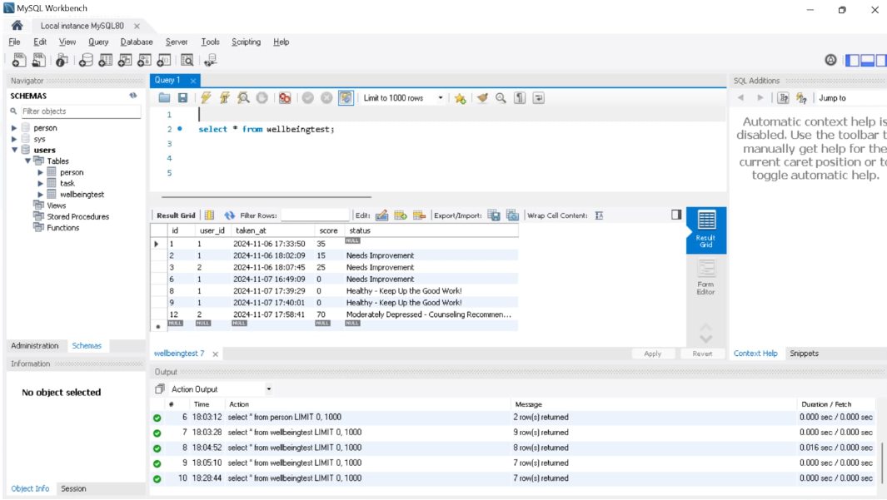

**Conclusion:**

This outline provides a foundational structure for a backend supporting a mental health questionnaire and assessment system.

**Milestone – 3:(module 4)**

The chatbot offers real-time assistance and answers to users’ queries about safety and wellness. It is designed to provide immediate responses and guide users through various features of the application.

**Dependencies:**

🡪Lombok

🡪spring data JPA

🡪Spring data MongoDB

🡪Spring web

🡪MySQL driver

**Packages & Classes:**

**🡪**Controller

* ChatLogController

🡪DTO

* MessageRequestDTO

🡪Exception

* GlobalExceptionHandler

🡪Model

* ChatLog
* MongoChatLog

🡪Repository

* ChatLogRepository
* MongoChatLogRepository

🡪Serive

* ChatLogService
* ChatLogServiceImpl

**Model :**

Define models to represent chatbot’s messages.

**Class: ChatLog**

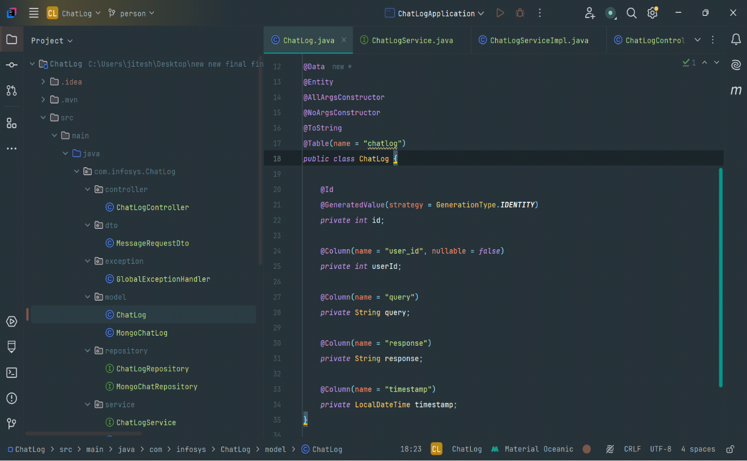

**Class : MongoChatLog**

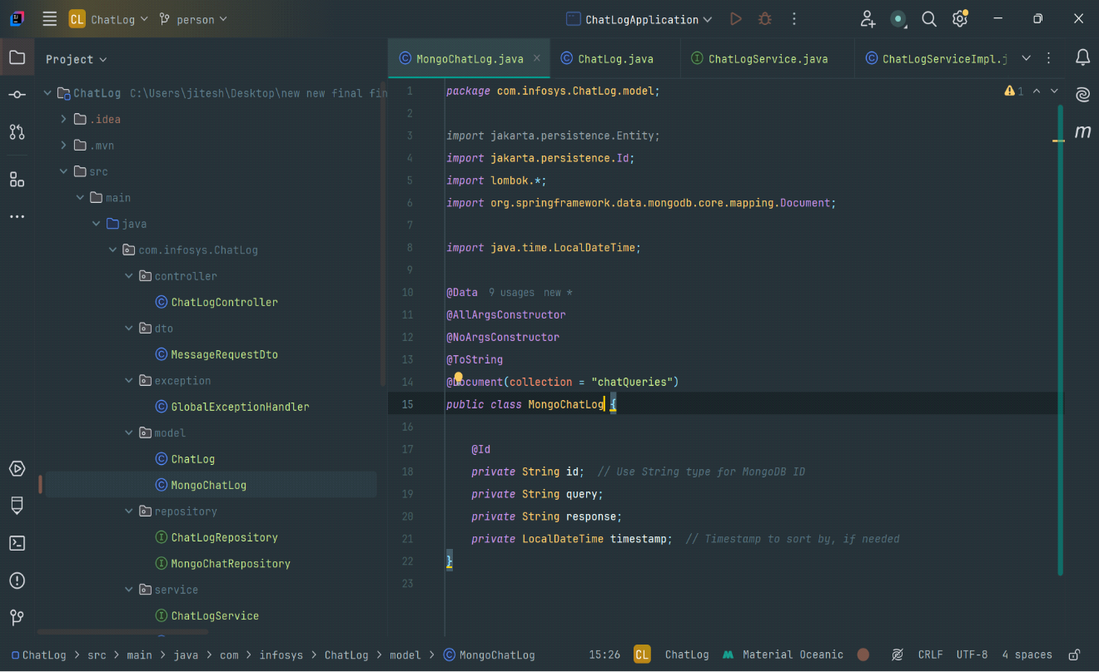

**DTOs:**

Define DTOs to control data sent to the client.

**Class: MessageRequestDTO**

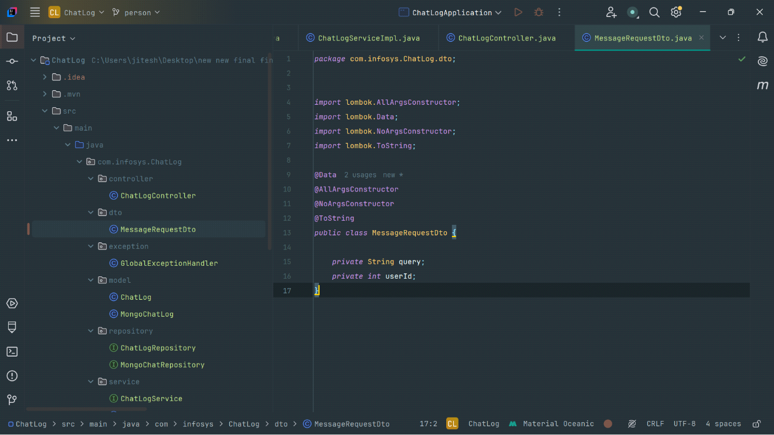

**Repository :**

Create Repositories to manage entities

**Class: ChatLogRepository**

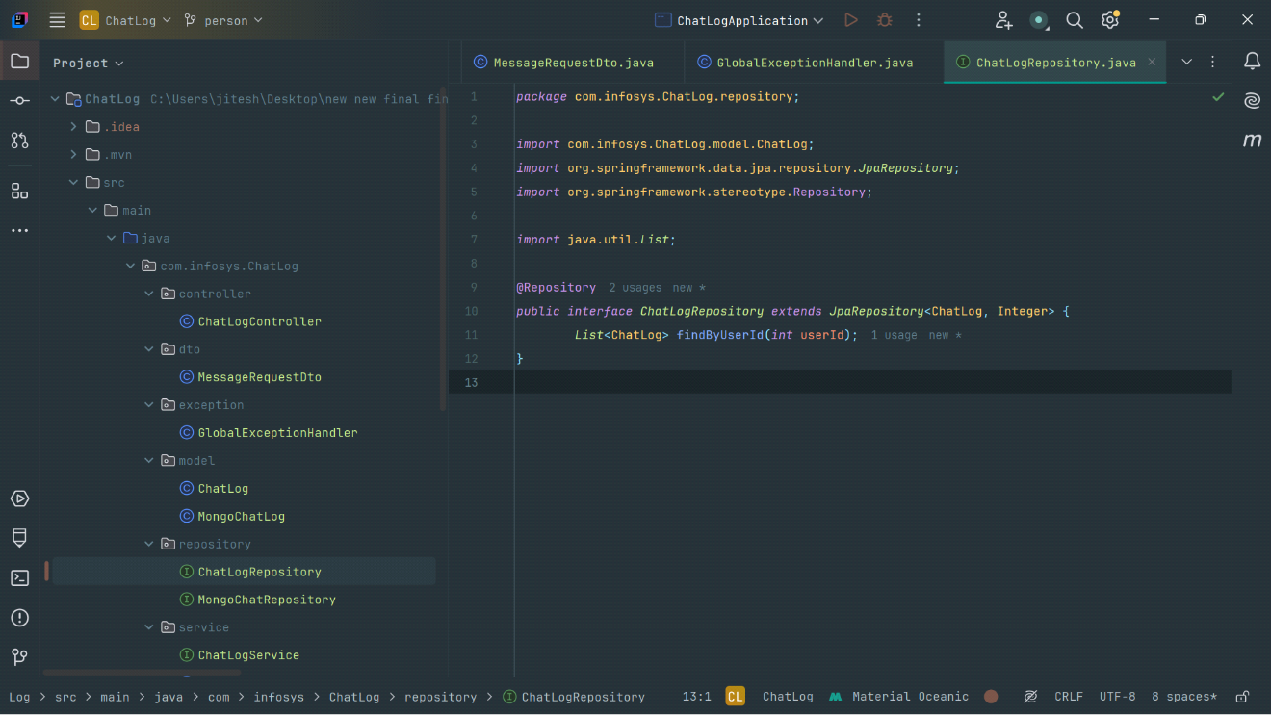

**Class: MongoChatLog**

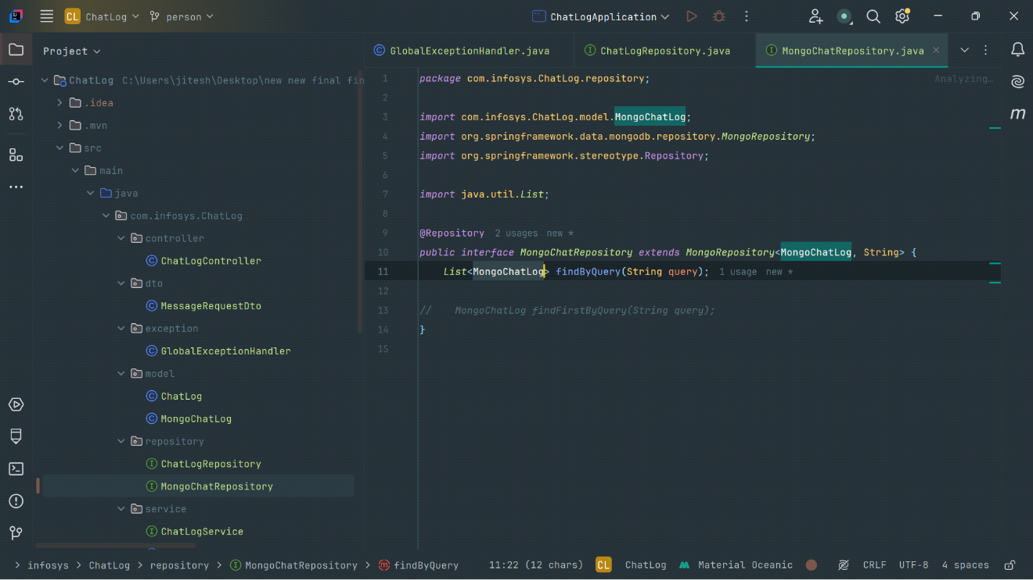

**Service:**

Create service classes to handle business logic, such as managing conversations and messages.

**Class: ChatLogService**

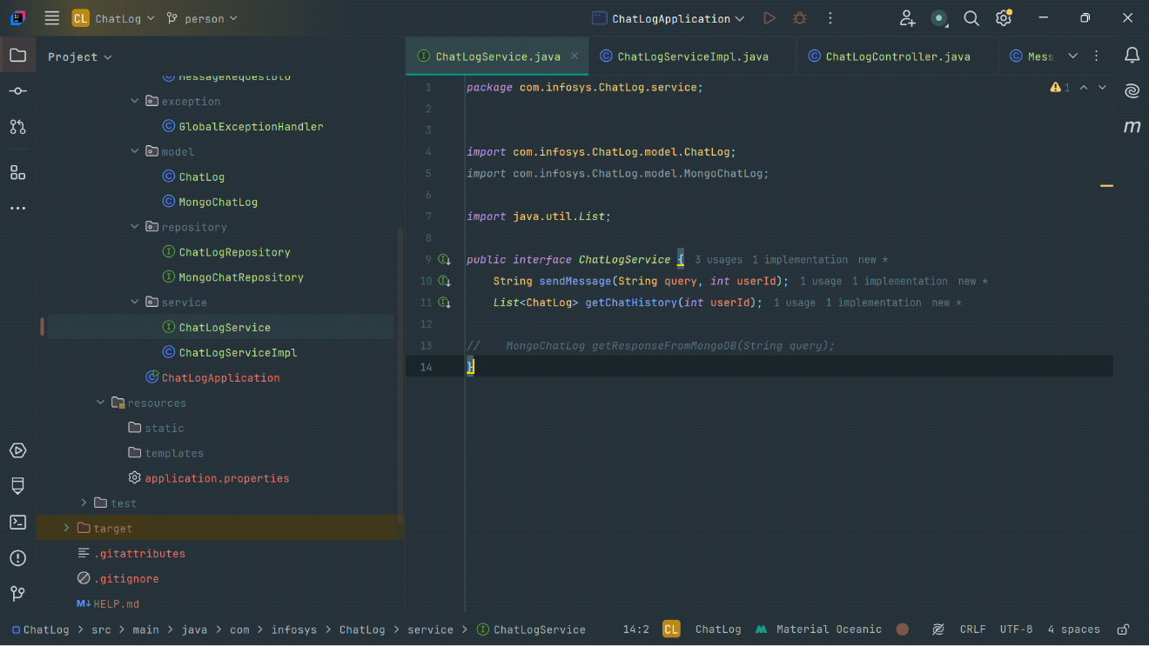

**Class: ChatLogServiceImpl**

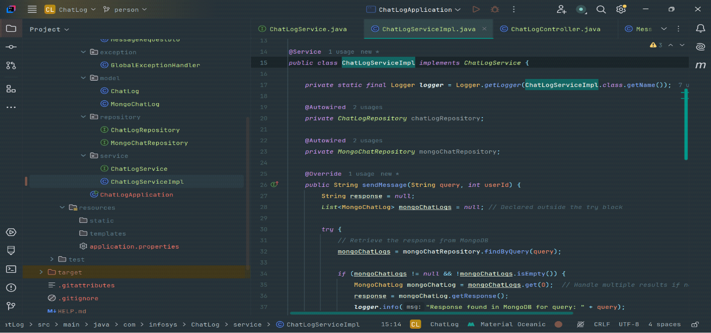

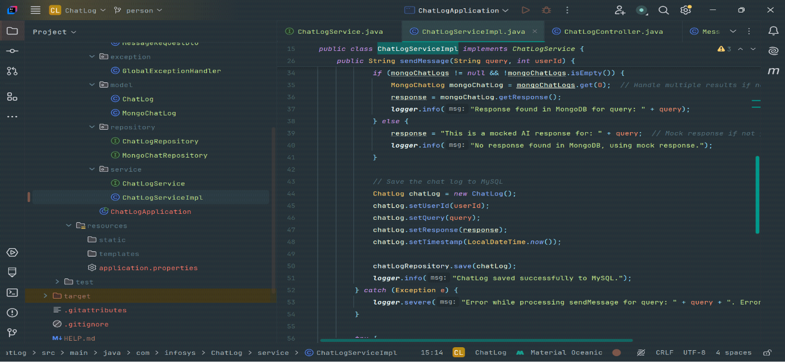

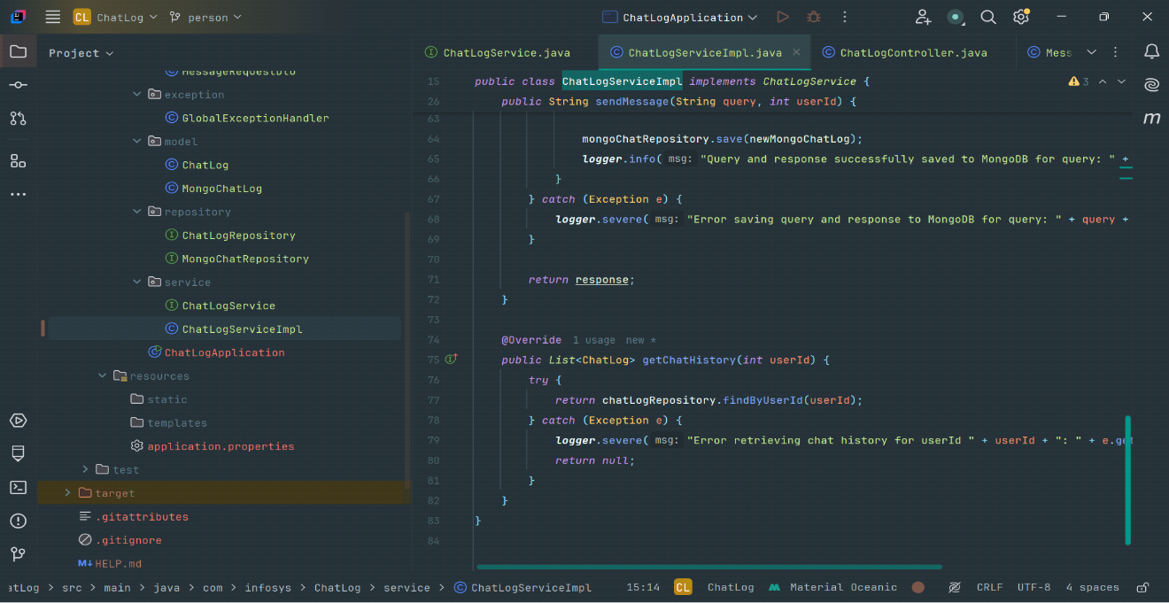

**Controller :**

Create REST endpoints for Chatbot interaction.

**Class: ChatLogController**

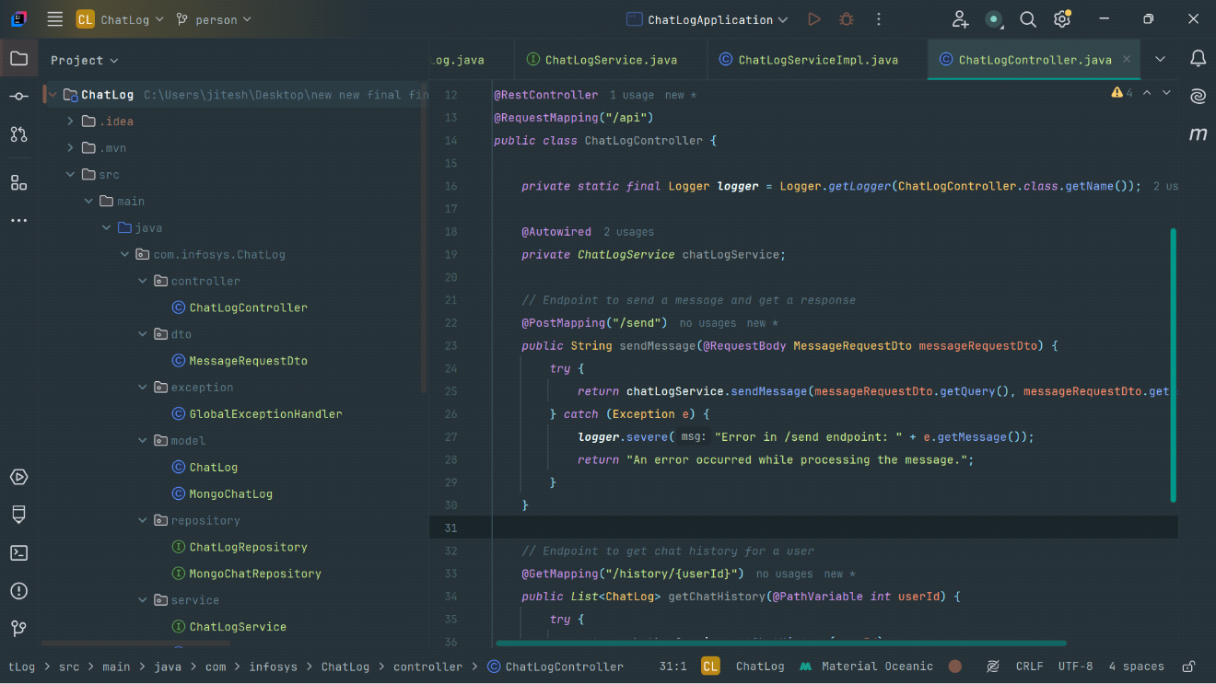

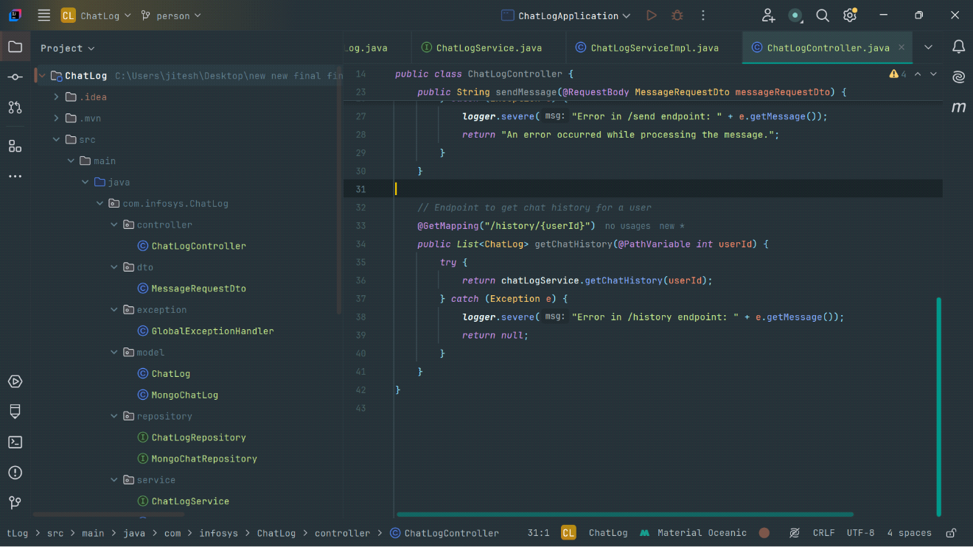

**Testing and Validation**

Test the application using Postman or other tools to ensure endpoints work as expected.

**GET**

<http://localhost:8080/api/history/2>

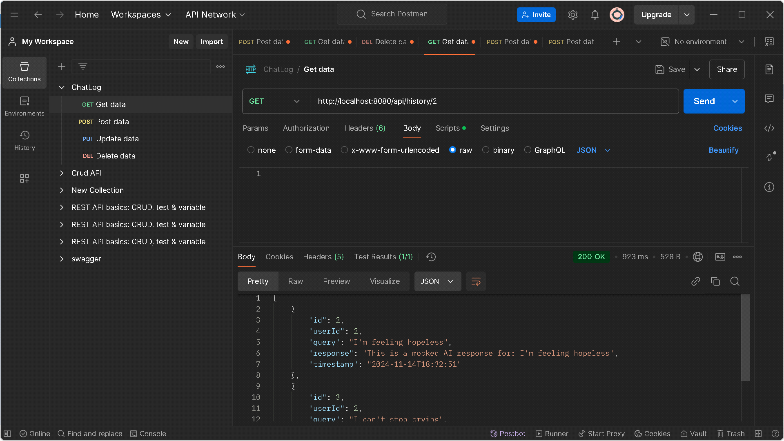

**POST**

<http://localhost:8080/api/send>

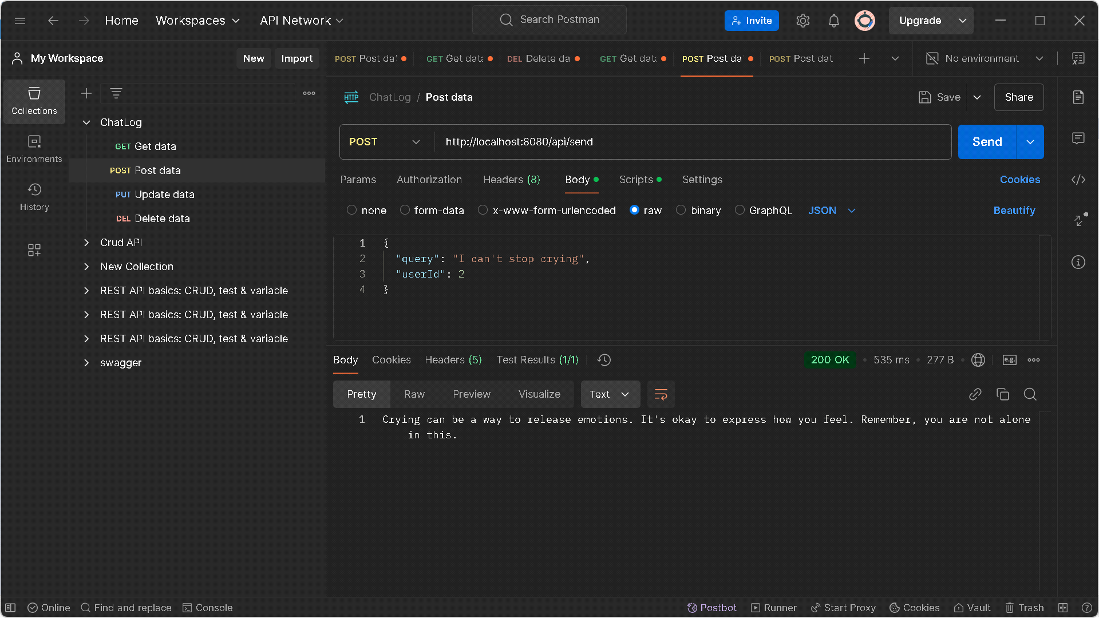

**Mongodb**

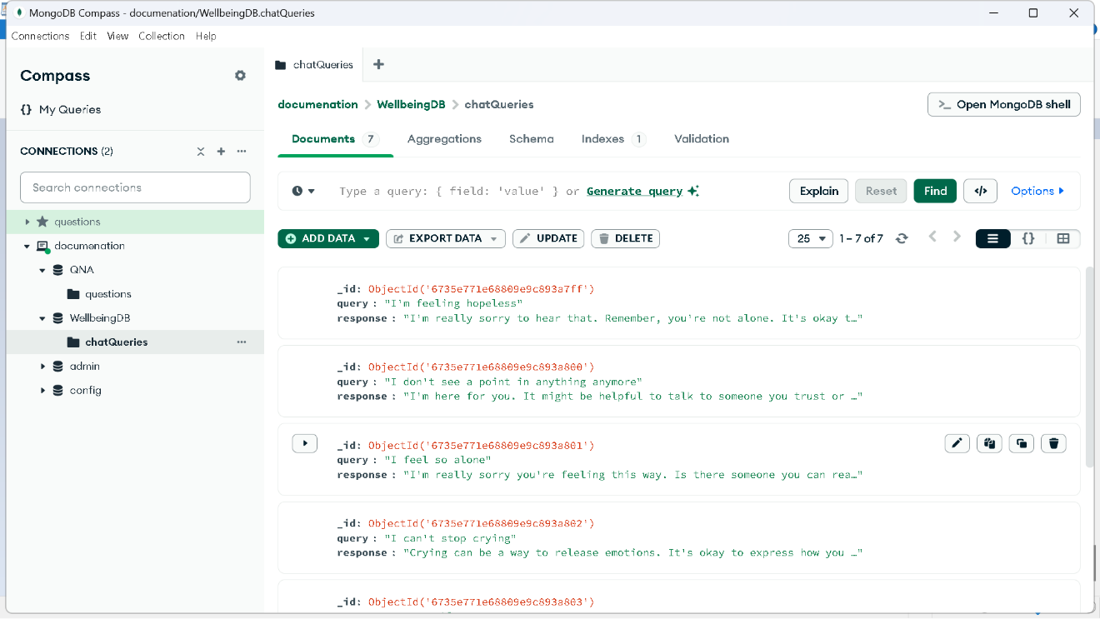

**Database for chatlog**

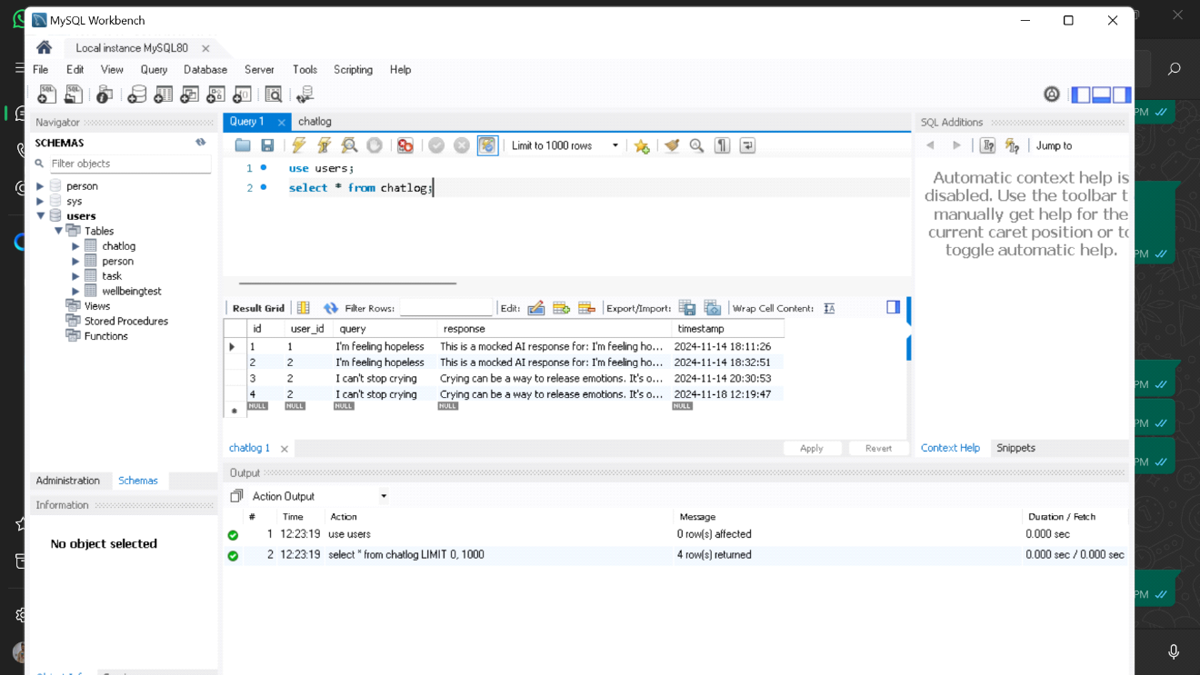

**Conclusion:**

This outline provides a foundational structure for a backend for managing users, conversations, and message handling, with the flexibility to integrate a chatbot AI for responses.

**Milestone 4: Task Management**

**Add Tasks:** Enter task details, set a due date, priority, and reminder.

**Modify Tasks:** Update task details, including title, due date, and reminder settings.

**DeleteTasks:** Remove tasks that are no longer needed.

**Reminders:** Receive notifications based on your reminder settings to keep track of tasks.

**Dependencies:**

🡪Lombok

🡪spring data JPA

🡪Spring web

🡪MySQL driver

**Packages & Classes:**

**🡪**Controller

* TaskController

🡪DTO

* TaskDto

🡪Exception

* GlobalExceptionHandler
* TaskNotFoundException

🡪Model

* Task

🡪Repository

* TaskRepo

🡪Serive

* TaskService
* TaskServiceImpl

**Model:**

Represents the data or entity structure that will be stored in the database.

**Class: Task**

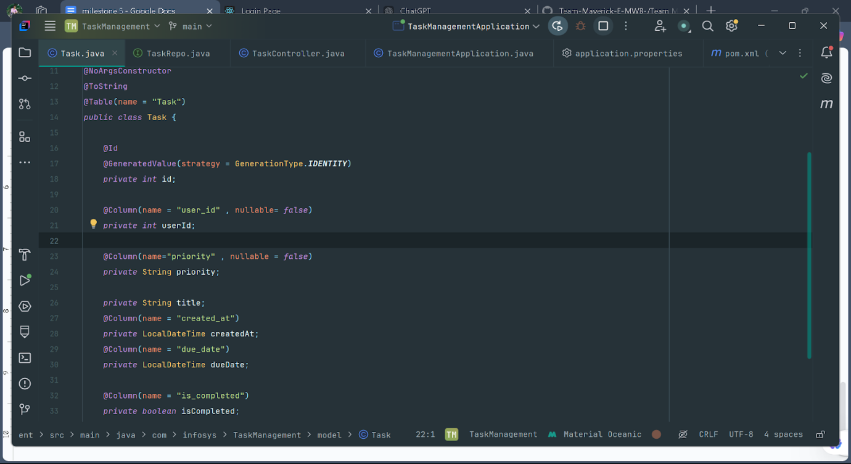

**Controller:**

Acts as the entry point for client requests (typically HTTP requests in a REST API).

**Class: TaskController**

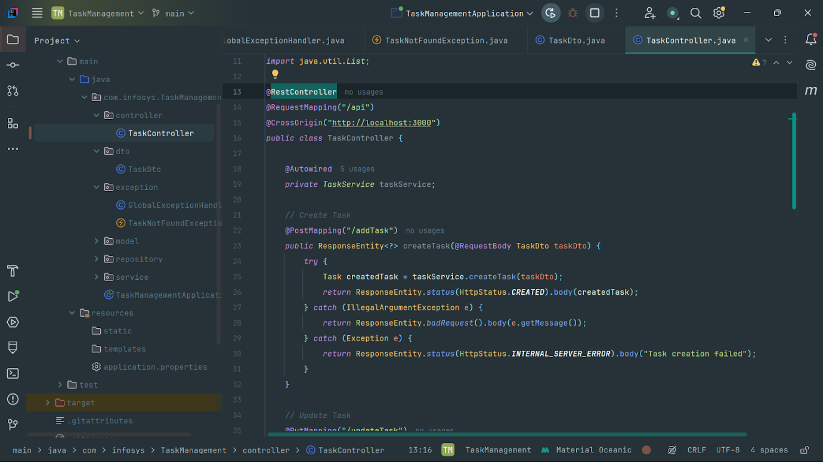

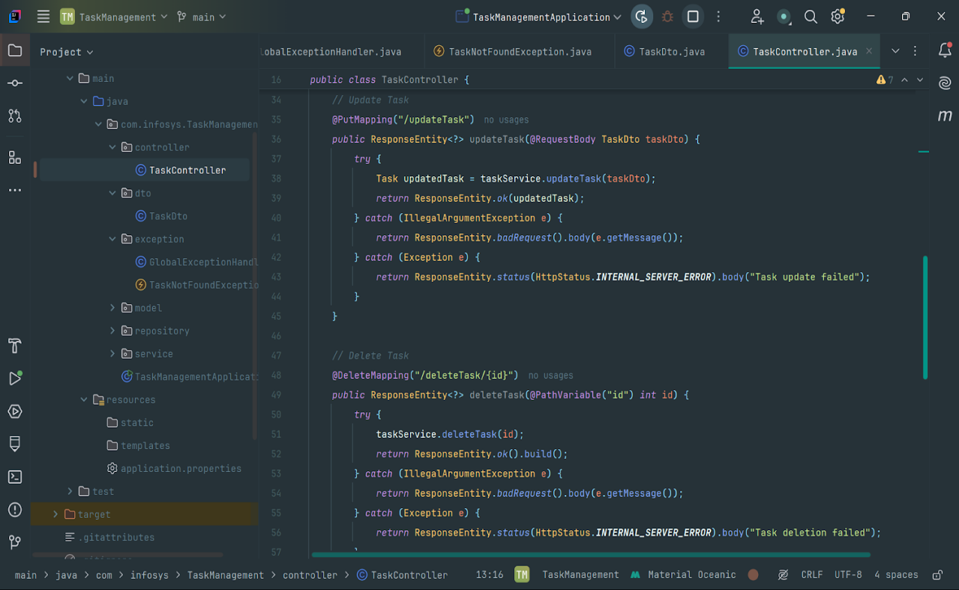

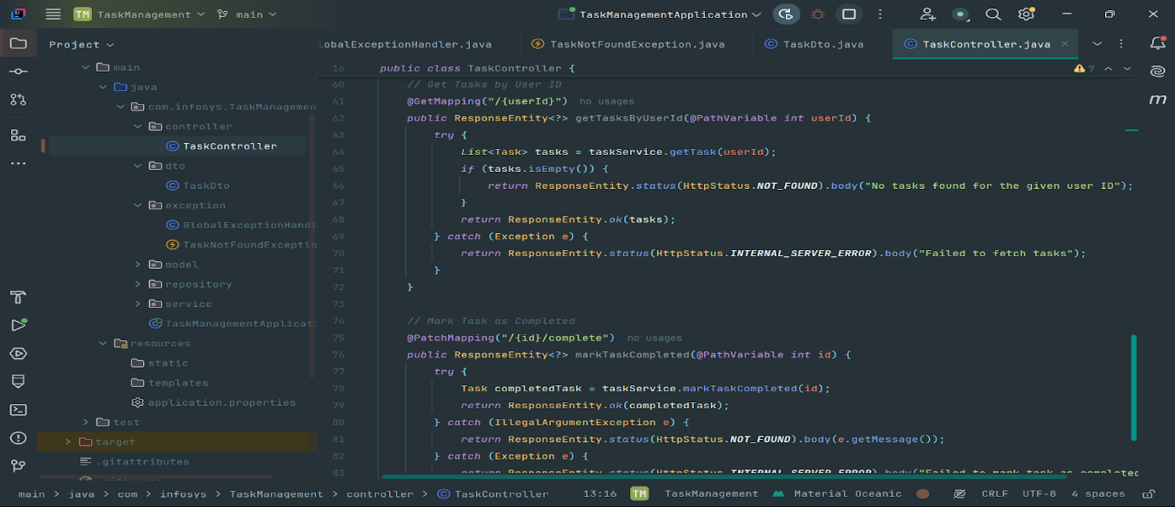

**Dto:**

Transfers data between different layers (especially between Controller and Service) without exposing the entity directly.

**Class: TaskDto**

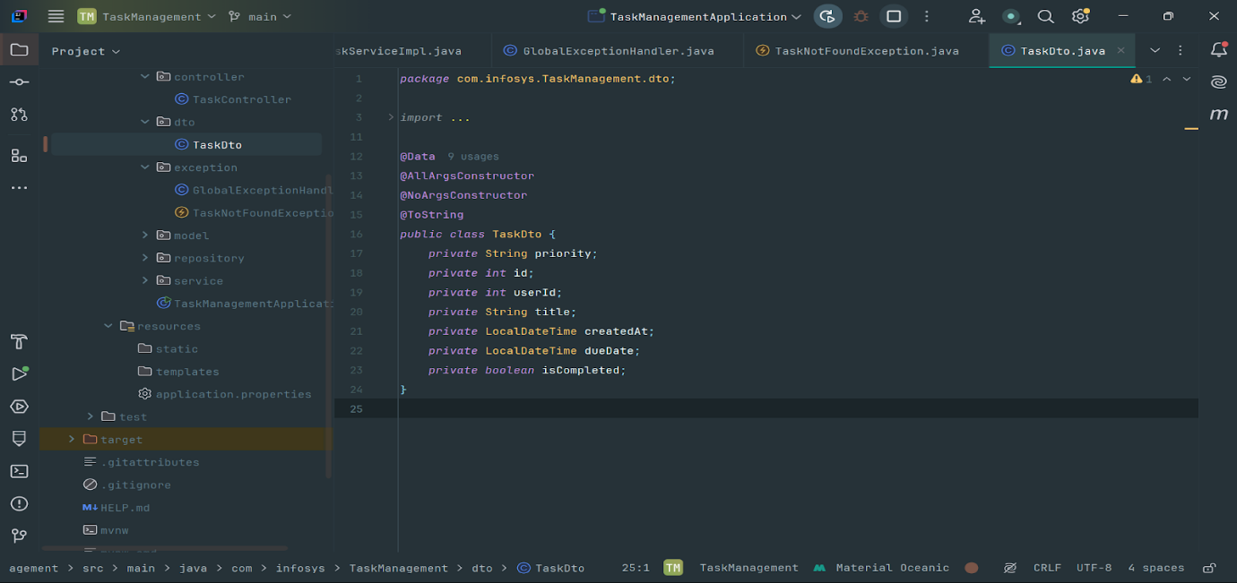

**Repository**

Handles the interaction with the database using JPA (Java Persistence API).

**Class: TaskRepo**

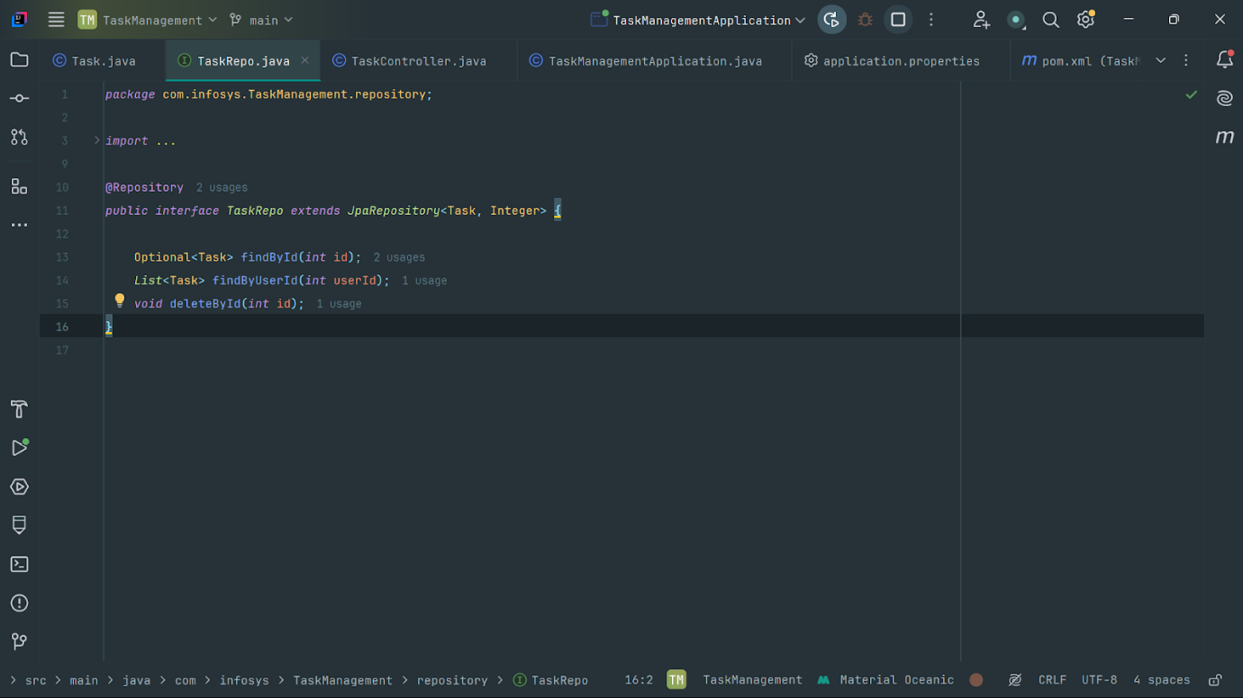

**Service:**

Contains the business logic. It processes the data and communicates between the Controller and Repository layers.

**Class: TaskService**

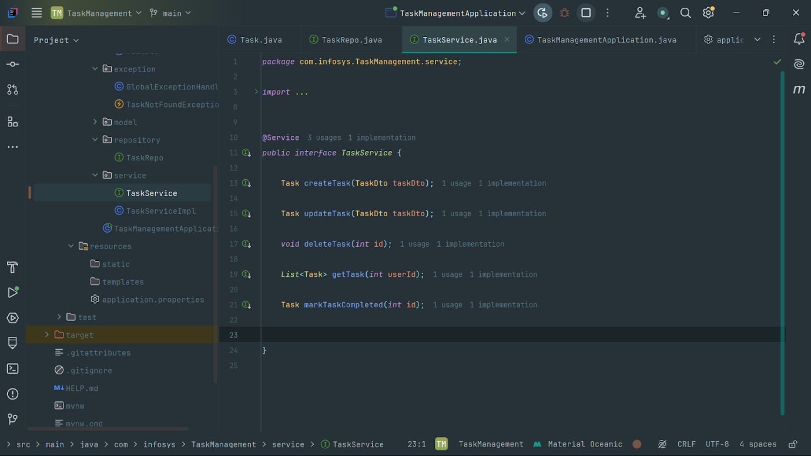

**Class: TaskServiceImpl**

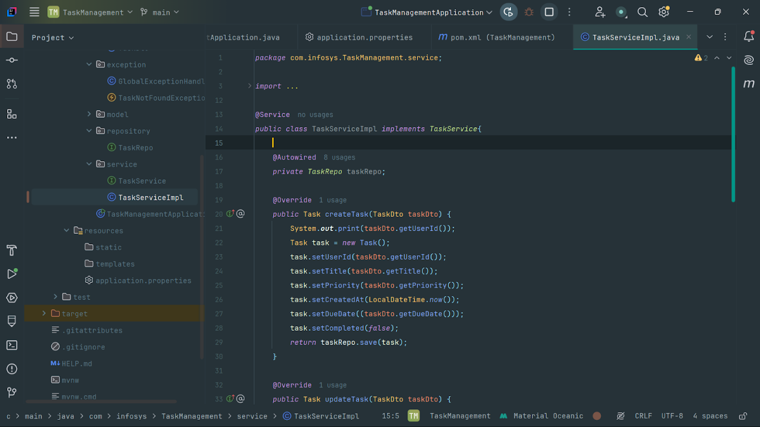

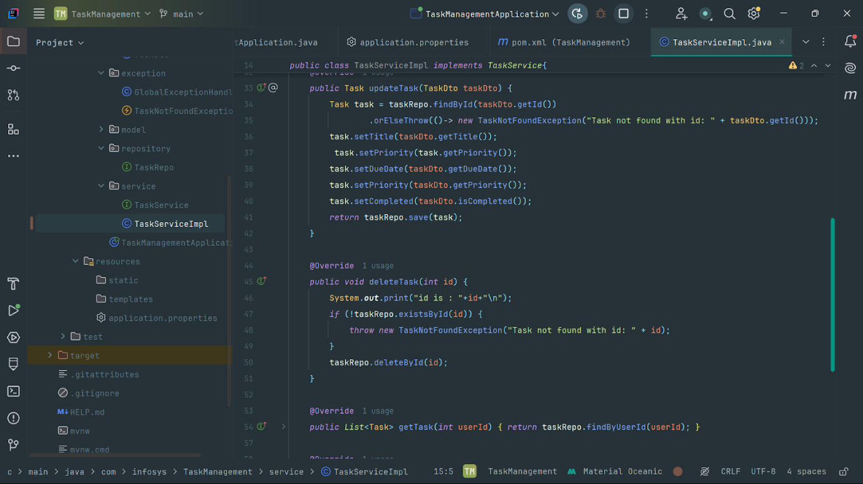

**Exception:**

Defines custom error scenarios.

**Class: GlobalExceptionHandler**

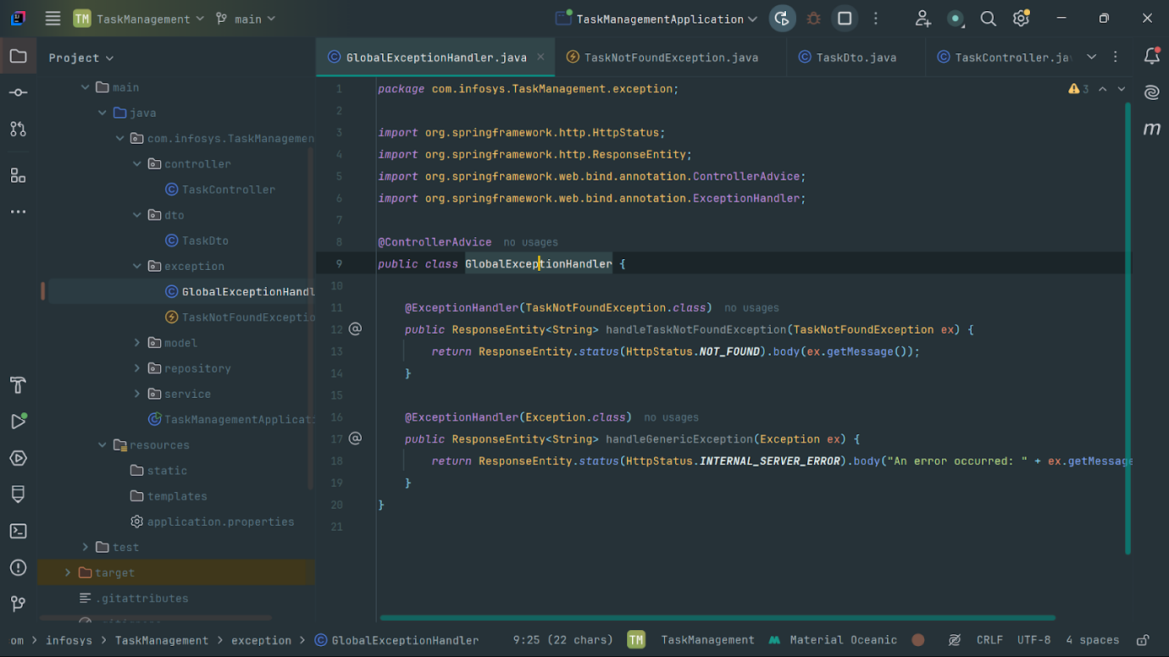

**Class: TaskNotFoundException**

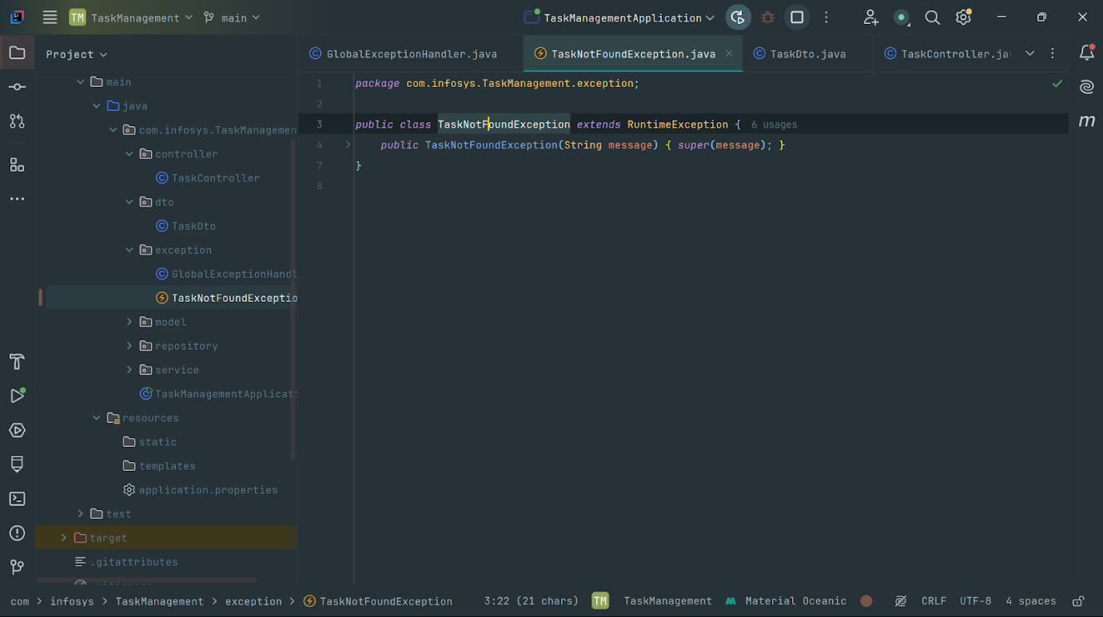

**Testing and Validation**

Test the application using Postman or other tools to ensure endpoints work as expected.

**POST: api/addTask**

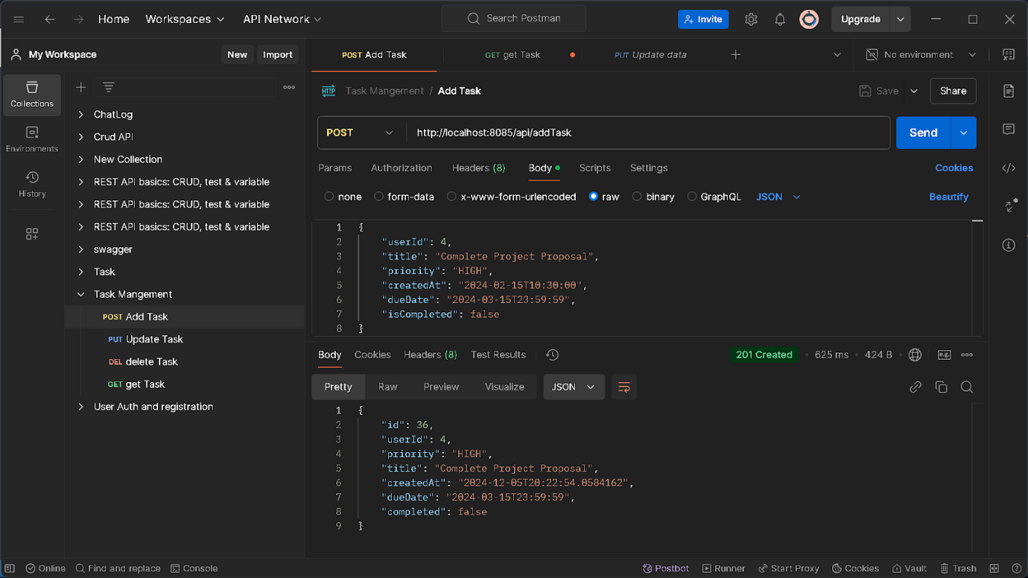

**PUT: api/updateTask**

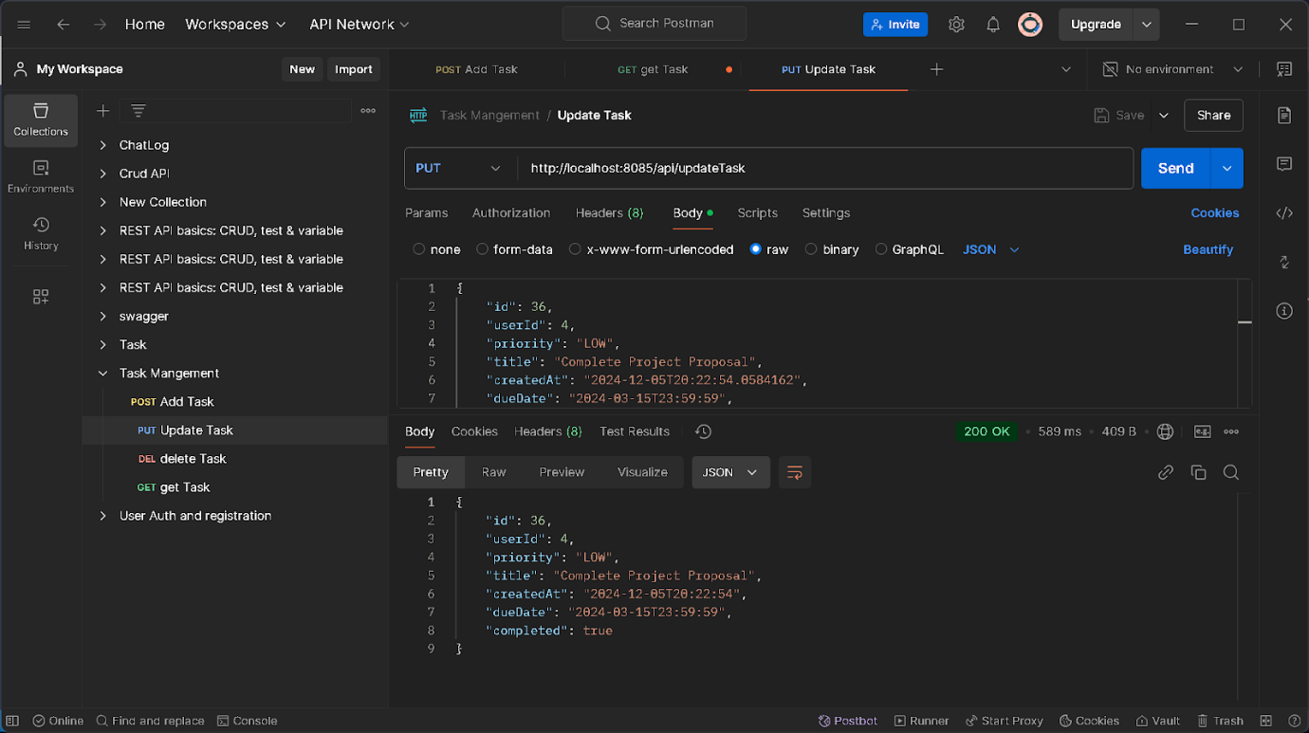

**GET : api/{userId}**

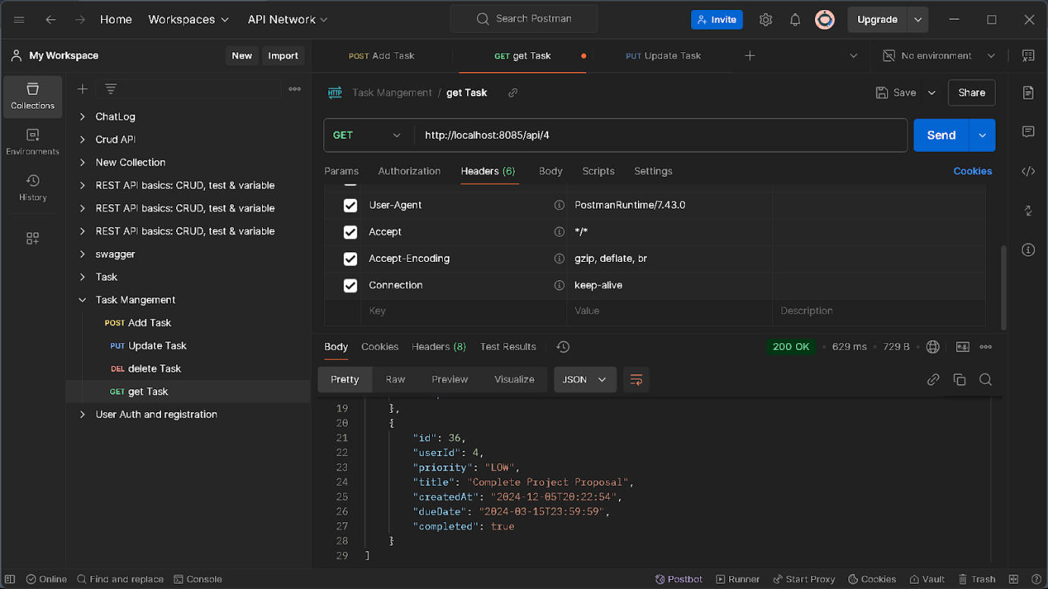

**DELETE : api/deleteTask/{id}**

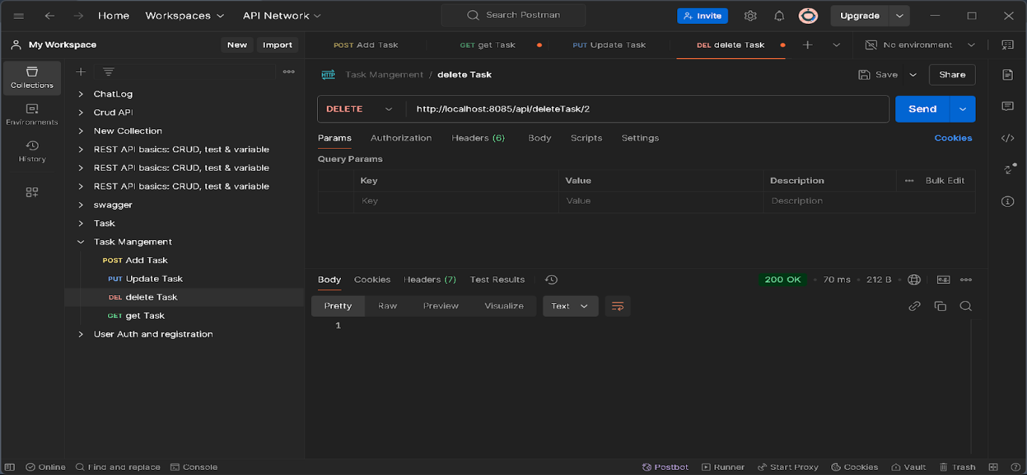

**Output**

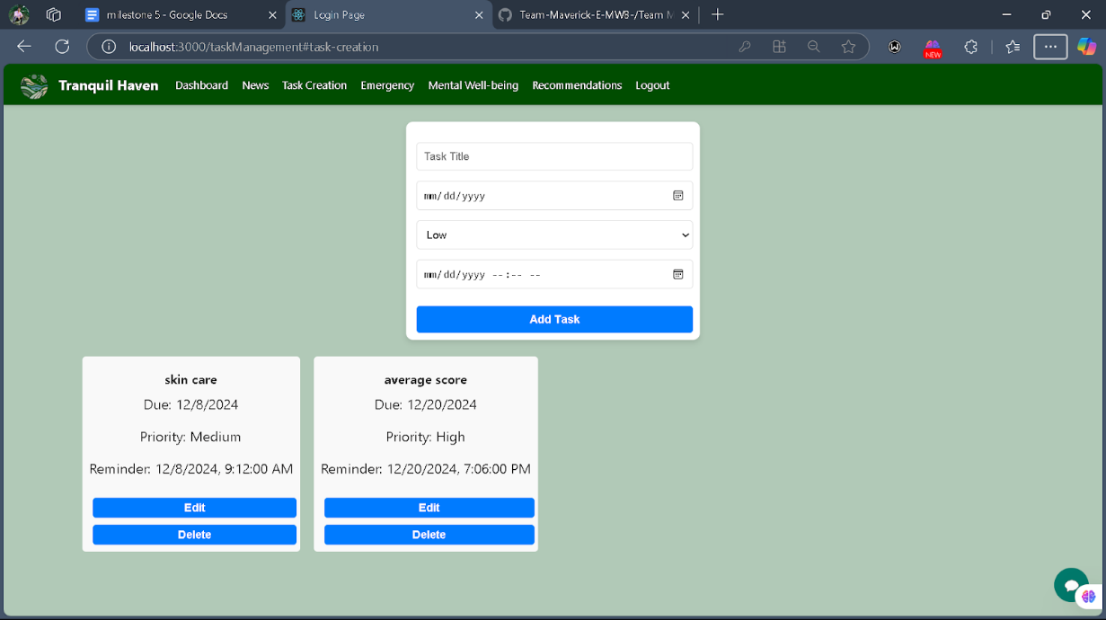

**Conclusion:**

This Outline provides a foundational structure for a backend for Task Management.